NEXTGEN QA: An AI-powered system that transforms Agile conversations into comprehensive, self-healing test suites

INDIVIDUAL THESIS
ABEYGUNASEKARA D.T
IT22303684
Individual component: Intelligent Test Case Generation
Group ID: R26-SE-039

Report submitted in partial fulfilment of the requirements for the
Bachelor of Science (Hons) in Information Technology

Specializing in Software Engineering
Department of Software Engineering

Sri Lanka Institute of Information Technology
Sri Lanka
October 2026

DECLARATION AND SUPERVISOR CERTIFICATION
Candidate declaration. I declare that this thesis is my own work and does not incorporate, without acknowledgement, material previously submitted for a degree or diploma at any university or institute of higher learning. To the best of my knowledge, it contains no material previously published or written by another person except where acknowledgement is made in the text. I grant the Sri Lanka Institute of Information Technology the non-exclusive right to reproduce and distribute this thesis, in whole or in part, in print, electronic, or other media, while retaining the right to use the content in future work.
Academic integrity and AI disclosure. I have disclosed all use of generative AI and other automated tools in accordance with the module policy. I remain responsible for the accuracy, originality, citations, code, data, analyses, and conclusions in this thesis.
Student name: [Full name]
Student ID: [Student ID]
Signature: ______________________________ Date: ____________

Supervisor certification. The above candidate carried out this research for the bachelor's degree thesis under my supervision.
Role and name | Signature | Date
Supervisor: Ms. Suriyaa Kumari
Co-supervisor: Mr. Eishan Weerasinghe

Abstract
Agile teams capture requirements faster than quality-assurance (QA) engineers can turn them into automated tests, and existing tools address only parts of this gap: record-and-playback tools produce brittle scripts, test-management tools store but do not generate tests, and large language model (LLM) generators produce plausible test code that is neither grounded in the real user interface nor independently checked. This thesis presents Component 2 of NextGen QA, an intelligent test case generation engine that converts structured user stories into Gherkin scenarios and executable Playwright, Selenium and Cypress suites grounded in the live application through a headless DOM crawler and executes them locally or through GitHub Actions. Two mechanisms form the research contribution: a vision-guided agent explorer that discovers application behavior using Set-of-Mark screenshot grounding, four-role reasoning, reflexion memory and a coverage-plateau stopping rule; and an independent validation gate that combines deterministic static analysis with an LLM judge running on a different model, producing per-scenario pass predictions, line-anchored findings and reviewable auto-fix proposals. The artefact was built using Design Science Research as a FastAPI and PostgreSQL micro-service with a React dashboard, integrated with the other three components through an API gateway and deployed on AWS behind a test-gated CI/CD pipeline. On the SauceDemo benchmark, 65 executions comprising 249 scenario runs gave a 72.7% pass rate (login 81.9%, checkout 70.6%, cart 66.7%) with 100% story-to-Gherkin coverage. The validation gate detected a dropped scenario, a checkout step that contradicted its scenario and unverified selectors in live suites and repaired a suite as a new version. A random-forest risk model reached 94.25% accuracy on synthetic bootstrap data, reported as pipeline validation only. The results show that generation and validation must be designed together; controlled ablations, fault-detection experiments and a practitioner study remain to be run.
Keywords: test case generation, large language models, behaviour-driven development, web agents, LLM-as-a-judge

ACKNOWLEDGEMENTS
I express my sincere gratitude to my supervisor, Ms. Suriyaa Kumari, and my co-supervisor, Mr. Eishan Weerasinghe, for their continuous guidance, critical feedback and encouragement throughout this research. Their insistence on measurable evidence and on independent validation of generated artefacts shaped the most important parts of this work.
I thank the research panel members whose comments at the progress presentations directed me towards the independent validation mechanism presented in Chapter 4, and the Faculty of Computing of the Sri Lanka Institute of Information Technology for its resources and research environment.
I am grateful to my team members on NextGen QA (R26-SE-039), who own Components 1, 3 and 4, for the collaborative integration work on the shared API gateway, authentication service and AWS deployment, and for the many hours of joint debugging.
Finally, I thank my family and friends for their patience and support during this project.

TABLE OF CONTENTS

1 INTRODUCTION 1
1.1 Overall project context 1
1.2 Individual component context 2
1.3 Problem statement 3
1.4 Research gap 4
1.5 Aim and objectives 4
1.6 Research questions or hypotheses 6
1.7 Scope limitations and assumptions 6
1.8 Individual contribution 7
1.9 Thesis structure 8
2 LITERATURE REVIEW AND RELATED WORK 9
2.1 Review method and scope 9
2.2 Domain and theoretical foundations 9
2.2.1 Behaviour-driven development and Gherkin 9
2.2.2 End-to-end UI test automation 10
2.2.3 Large language models for code 10
2.2.4 Visual grounding and agent reasoning 11
2.2.5 Test prioritisation and APFD 11
2.2.6 LLM-as-a-judge 11
2.3 Related research 12
2.3.1 Requirements-to-test and BDD scenario generation 12
2.3.2 LLM-based test code generation 12
2.3.3 GUI and web agents 13
2.3.4 Test prioritisation and risk prediction 13
2.3.5 Validation of LLM output 14
2.4 Existing systems products and techniques 14
2.5 Gap synthesis and conceptual framework 16
3 RESEARCH METHODOLOGY 17
3.1 Research design 17
3.2 Data participants or study materials 18
3.3 Experimental or study procedure 19
3.3.1 Operational evaluation of generation and execution 19
3.3.2 Validation gate evaluation 19
3.3.3 Risk model training 20
3.3.4 Agent explorer runs 20
3.3.5 Software verification 20
3.3.6 Controlled experiments specified for completion 20
3.4 Measures and evaluation metrics 21
3.5 Data analysis 22
3.6 Ethics privacy security and responsible AI 23
3.7 Reproducibility and research artefacts 24
4 PRODUCT AND SOLUTION DESIGN 25
4.1 Requirements 25
4.1.1 Requirement gathering and analysis 25
4.1.2 Functional requirements 25
4.1.3 Non-functional requirements 26
4.1.4 Feasibility study 27
4.2 Component architecture within the complete solution 28
4.2.1 Platform architecture 28
4.2.2 Component pipeline 29
4.2.3 Use cases 31
4.3 Design alternatives and decisions 32
4.4 Detailed design 33
4.4.1 User story intake 34
4.4.2 Gherkin scenario generator 34
4.4.3 DOM crawler and element map 34
4.4.4 Dual-mode multi-framework code generator 35
4.4.5 Deterministic sanitizer 36
4.4.6 Vision-guided agent explorer 36
4.4.7 Execution engine 39
4.4.8 Independent validation gate 39
4.4.9 LLM auto-fix loop 42
4.4.10 ML risk prediction 43
4.4.11 Reporting and traceability 44
4.5 Standards and professional practice 44
5 IMPLEMENTATION INTEGRATION AND TESTING 46
5.1 Development environment and technology stack 46
5.2 Component implementation 47
5.2.1 Project structure 47
5.2.2 Data model and startup migration 48
5.2.3 REST and WebSocket API 50
5.2.4 Code generation and versioning flow 51
5.2.5 Validation engine internals 52
5.2.6 GitHub Actions runner and workflow installation 53
5.3 Integration with the other components 53
5.4 Verification and software testing 54
5.4.1 Test plan and strategy 54
5.4.2 Test case design 55
5.5 Deployment and operation 58
6 RESULTS AND VALIDATION 59
6.1 Research results 59
6.1.1 Generation quality 59
6.1.2 Pass rate by flow 61
6.1.3 Independent validation gate 62
6.1.4 Agent explorer 65
6.1.5 Risk model 66
6.2 Product and technical results 69
6.3 User or stakeholder validation 71
6.4 Integration results 71
6.5 Summary of findings 72
7 DISCUSSION 75
7.1 Interpretation of findings 75
7.2 Comparison with literature baselines and existing solutions 76
7.3 Research contribution 77
7.4 Product contribution 78
7.5 Limitations and threats to validity 78
7.6 Implications 79
8 COMMERCIALISATION AND SUSTAINABILITY 80
8.1 Value Proposition and Target Users 80
8.2 Market and Competitive Position 80
8.3 Business and Sustainability Model 81
8.4 Scalability, Intellectual Property and Compliance 82
8.5 Contribution to the Sustainable Development Goals 82
9 CONCLUSION AND FUTURE DIRECTIONS 84
9.1 Conclusion 84
9.2 Achievement of Objectives 84
9.3 Individual Research and Product Contributions 86
9.4 Future Directions 86
REFERENCES 88
GLOSSARY 91
APPENDICES 93
Appendix A Extended Results and Sample Artefacts 93
A.1 Generated Gherkin (login story, LLM generator, lean policy) 93
A.2 Generated Playwright suite excerpt (Mode B, DOM-aware) 93
A.3 Validation report for Playwright suite v28 (abridged JSON) 94
A.4 Judge prompt (abridged) 94
A.5 Configuration of the evaluated deployment 95
A.6 Deployment workflow (abridged) 95
A.7 Evaluation scripts 95
Appendix B Academic Integrity and AI Use Disclosure 96
Appendix C Dashboard Screenshots 97
Appendix D Similarity (Turnitin) Report 99

LIST OF FIGURES

Figure | Title | Page
Figure 1.1 | Position of Component 2 in the NextGen QA closed loop
Figure 2.1 | Conceptual framework linking research gaps, mechanisms and research questions
Figure 3.1 | Design Science Research process applied to Component 2
Figure 4.1 | NextGen QA deployment architecture
Figure 4.2 | Component 2 six-stage pipeline
Figure 4.3 | Use case diagram for Component 2
Figure 4.4 | Sequence diagram: story to executable suite
Figure 4.5 | Sequence diagram: one agent-explorer iteration
Figure 4.6 | Coverage-plateau termination flow
Figure 4.7 | Validation score composition
Figure 4.8 | Sequence diagram: validate, auto-fix and re-validate
Figure 5.1 | Entity relationship diagram of the Component 2 schema
Figure 5.2 | Suite version chain and validation report linkage
Figure 5.3 | Integration of Component 2 with the platform and Components 1, 3 and 4
Figure 5.4 | Test-gated deployment pipeline
Figure 6.1 | Coverage funnel from stories to passing runs
Figure 6.2 | Test-run outcomes
Figure 6.3 | Pass rate by flow
Figure 6.4 | Validation panel in the suite editor
Figure 6.5 | Auto-fix diff dialog with change log
Figure 6.6 | Gherkin editor with validation panel and acceptance-criteria coverage
Figure 6.7 | Agent Explorer live view with Set-of-Mark overlay and reasoning cards
Figure 6.8 | Risk model confusion matrix
Figure 6.9 | Risk model per-class metrics
Figure 6.10 | Risk model feature importance
Figure 6.11 | Training-set class distribution
Figure 6.12 | Code Review page with validation badges and summary strip
Figure 6.13 | Execution page with live log, screenshots and PDF report
Figure 6.14 | Public OpenAPI (Swagger) documentation of the Component 2 service
Figure C.1 | User Stories page with Import from Meetings
Figure C.2 | Mode Setup page
Figure C.3 | DOM Inspector
Figure C.4 | Suite Editor with validation panel and jump-to-line
Figure C.5 | GitHub Settings

LIST OF TABLES

Table | Title | Page
Table 1.1 | Sub-objectives mapped to modules and evaluation metrics
Table 2.1 | Comparison of existing approaches against the identified gap
Table 3.1 | Study materials and evaluated configuration
Table 3.2 | Evaluation metrics, definitions and measurement status
Table 4.1 | Functional requirements
Table 4.2 | Non-functional requirements
Table 4.3 | Development schedule by month
Table 4.4 | Design alternatives and decisions
Table 4.5 | Generation modes
Table 4.6 | Deterministic checks for test suites
Table 4.7 | Deterministic checks for Gherkin
Table 4.8 | Validation score rules
Table 4.9 | Risk model feature schema
Table 5.1 | Technology stack
Table 5.2 | Backend package structure
Table 5.3 | Database tables
Table 5.4 | REST endpoints
Table 5.5 | Integration interfaces with the other components
Table 5.6 | Test strategy by level
Table 5.7 | Representative test cases
Table 6.1 | Generation-quality metrics
Table 6.2 | Pass rate by flow
Table 6.3 | Validation gate results on live suites
Table 6.4 | Risk model metrics
Table 6.5 | Functional requirements delivered
Table 6.6 | Targets versus achieved
Table 9.1 | Achievement of sub-objectives
Table A.1 | Evaluation scripts and outputs
Table B.1 | Generative AI tools used

LIST OF ABBREVIATIONS

Abbreviation | Meaning
AC | Acceptance Criteria
AI | Artificial Intelligence
APFD | Average Percentage of Faults Detected
API | Application Programming Interface
AWS | Amazon Web Services
BDD | Behaviour-Driven Development
BFS | Breadth-First Search
CI/CD | Continuous Integration / Continuous Delivery
CORS | Cross-Origin Resource Sharing
CSS | Cascading Style Sheets
DOM | Document Object Model
DSR | Design Science Research
E2E | End-to-End
EC2 | Elastic Compute Cloud
FR | Functional Requirement
GDPR | General Data Protection Regulation
HTTP | Hypertext Transfer Protocol
HTTPS | Hypertext Transfer Protocol Secure
JSON | JavaScript Object Notation
JWT | JSON Web Token
LLM | Large Language Model
MAE | Mean Absolute Error
ML | Machine Learning
NFR | Non-Functional Requirement
ORM | Object-Relational Mapping
PAT | Personal Access Token
PDF | Portable Document Format
QA | Quality Assurance
REST | Representational State Transfer
RF | Random Forest
RQ | Research Question
RTM | Requirements Traceability Matrix
SaaS | Software as a Service
SDG | Sustainable Development Goal
SHA | Secure Hash Algorithm
SMOTE | Synthetic Minority Over-sampling Technique
SO | Sub-objective
SoM | Set-of-Mark
SPA | Single-Page Application
SSL | Secure Sockets Layer
TLS | Transport Layer Security
UI | User Interface
UUID | Universally Unique Identifier
VLM | Vision-Language Model
WS | WebSocket
YAML | YAML Ain't Markup Language

INTRODUCTION
Software quality depends on testing, yet testing remains the slowest and most labor-intensive part of the delivery pipeline. Agile and continuous delivery have accelerated how often teams ship, but the work between a requirement spoken in a sprint meeting and a passing automated test has barely changed. A business analyst writes a story, a QA engineer derives test cases by hand, an automation engineer hand-codes scripts, failures are triaged manually, and traceability between requirements and tests is kept in spreadsheets. Each hand-off loses information and time, and the resulting scripts decay as soon as the user interface changes because their locators are hard-coded.
This chapter introduces the NextGen QA platform and the position of Component 2 within it, states the problem and the research gap, and sets out the aim, objectives, research questions, scope and the author's individual contribution.

Overall project context
NextGen QA is a four-component research platform that treats this fragmented process as one closed loop, from a requirement spoken in a meeting to a validated, traceable test result. The four components are:
- Component 1 — Meeting-to-story conversion. Converts meeting speech into structured user stories.
- Component 2 — Intelligent test case generation (this thesis). Converts stories into Gherkin scenarios and executable, UI-grounded test suites, runs them and validates them independently.
- Component 3 — Failure analysis and self-healing. Classifies test failures and repairs broken locators.
- Component 4 — Traceability and quality prediction. Maintains a live requirements traceability matrix (RTM) and predicts quality.
The components are deployed as micro-services behind one application programming interface (API) gateway, share an authentication service that owns organizations, projects and iterations, and are presented through a single merged React dashboard. Figure 1.1 shows how artefacts flow through the platform and where Component 2 sits.
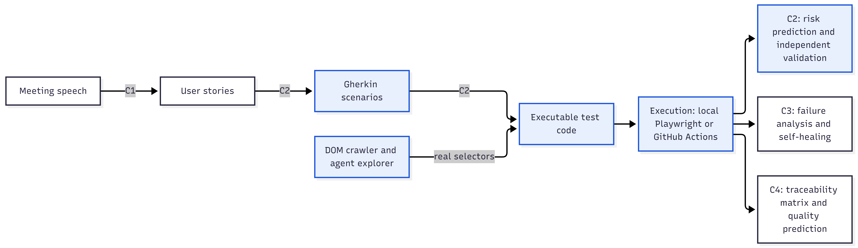
Figure 1.1: Position of Component 2 in the NextGen QA closed loop (shaded nodes belong to Component 2)

Component 2 is the hinge of the loop. Everything upstream of it is a description of intended behavior; everything downstream depends on executable tests and their results. If its tests are not grounded in the real application, Component 3 spends its effort healing locators that were never correct, and Component 4 traces requirements to tests that cannot fail.

Individual component context
Two developments make this problem newly tractable. First, large language models (LLMs) can now write syntactically correct test code for common frameworks from natural-language descriptions [4], [5], [23]. Second, multimodal models can interpret screenshots of a user interface, which enables agents that explore an application the way a human tester would [9], [10]. Both capabilities share a documented weakness: their output is plausible rather than verified. A generated test may reference a locator that does not exist, may skip the assertion that would make it meaningful, or may encode a wrong expectation. Without an independent check, the human reviewer is the only safeguard, which does not scale.
Component 2 therefore treats generation and validation as inseparable. Its inputs are approved user stories, imported from Component 1 or entered manually with acceptance criteria, and the URL of a target web application. Its outputs are Gherkin features approved by a QA engineer, versioned test suites for Playwright, Selenium and Cypress, per-scenario execution results with screenshots and PDF reports, validation reports with explainable scores, and a risk level per application flow. It feeds Component 3 with failed tests and the crawled element map, and Component 4 with traceability links from story to execution.
Internally, the component is organized as six stages: story intake, Gherkin generation and approval, mode setup and Document Object Model (DOM) inspection, code generation and review, execution, and downstream feeds. An autonomous agent explorer sits beside the inspection stage, and the independent validation gate wraps the Gherkin and code stages (Section 4.2).

Problem statement
Teams that adopt LLM-based generation for user interface (UI) tests face three linked problems. Generated code is written without seeing the application and therefore guesses locators. Generation covers only what the stories state, so behavior that nobody wrote down goes untested. And nothing independent of the generator tells the reviewer whether a generated test will pass, whether it asserts anything, or whether it implements every scenario it should.
The problem addressed by this component is stated as follows:
How can executable UI test suites be generated automatically from Agile user stories such that they are grounded in the real application, discoverable beyond what the stories state, and independently validated before execution, within a closed continuous integration and continuous delivery (CI/CD) loop?
The practical constraints are those of a four-component student research system: a single shared deployment, pluggable LLM providers with cost limits, one primary benchmark application (SauceDemo) with built-in seeded-defect accounts, and human-in-the-loop approval at each stage.

Research gap
The literature reviewed in Chapter 2 shows that each ingredient exists in isolation, but no system takes a user story to a grounded, executable, independently validated test suite in one loop. Four gaps stand out:
- Generation without grounding. LLM test generators hallucinate locators because they never see the application; recorders see the application but cannot generate from requirements [8].
- Exploration without a stopping rule. Web agent’s complete tasks but have no notion of “enough coverage” with which to decide that test discovery is complete [10], [11].
- Validation that is absent or self-referential. Generated tests are accepted on the generator's word and the reviewer's time; where a model grades the output, it is usually the same model, which the LLM-as-a-judge literature warns against [19].
- No measurement loop. Generated suites are rarely executed at scale with their results persisted, so predicted quality is never compared with actual outcomes.
Section 2.5 synthesises these gaps against existing systems (Table 2.1) and presents the conceptual framework that links each gap to a mechanism of Component 2.

Aim and objectives
Aim. To design, implement and evaluate an intelligent test case generation engine that converts structured user stories into independently validated, executable, multi-framework UI test suits grounded in the live application, and that closes the loop from requirement to CI/CD result within the NextGen QA platform.
The aim is decomposed into eight sub-objectives (SO), each owned by one backend module and measured by a primary metric, as listed in Table 1.1.

Table 1.1: Sub-objectives mapped to modules and evaluation metrics
# | Sub-objective | Module | Primary metric
SO1 | Generate human-readable, editable Gherkin from user stories with a template-first, LLM-fallback strategy and QA approval | gherkin/ | Story-to-Gherkin coverage; acceptance-criteria traceability; practitioner rating
SO2 | Crawl a live application to build a semantic element map (role, selector, confidence) with authentication handling | dom_crawler/ | Selector accuracy against manual ground truth
SO3 | Generate executable suites for Playwright, Selenium and Cypress in two modes (abstract, DOM-aware) with deterministic post-processing | code_gen/ | Executability and pass rate per mode and framework
SO4 | Build a vision-guided agent that explores the application, discovers scenarios and terminates on coverage plateau | agent_explorer/ | Unique UI states against a baseline crawler; steps to plateau
SO5 | Execute suites locally or through GitHub Actions with live logs, screenshots, PDF reports and per-scenario persistence | execution/, github_connection/ | End-to-end time; executions logged
SO6 | Validate every generated artefact independently (static checks and an LLM judge on a different model), score it explainably and offer reviewable auto-fix | validation/ | Findings precision; calibration of predicted against actual pass rate; score before and after fix
SO7 | Prioritise execution with an ML risk model and expose risk per flow | ml/ | Classification report; APFD (planned)
SO8 | Integrate with C1 (story import), C3 (failed tests, selectors) and C4 (traceability) through the shared gateway, and deploy with a test-gated CI/CD pipeline | integration/, deployment | Integration endpoints live; deployment gate passing

Research questions or hypotheses
The research problem decomposes into four research questions (RQ), each with a working hypothesis that the evaluation in Chapter 6 tests or prepares to test.
- RQ1 (Grounding). Does grounding LLM generation in crawled DOM selectors (Mode B) improve the executability and pass rate of generated UI tests compared with ungrounded generation (Mode A and naive prompting)? Hypothesis: Mode B yields higher executability and pass rate than Mode A and naive prompting on the same stories.
- RQ2 (Discovery). Can a vision-guided agent with Set-of-Mark grounding, multi-role reasoning and reflexion memory discover application behaviour and test scenarios autonomously, and can a novel-state plateau criterion bound that exploration without losing coverage? Hypothesis: the plateau criterion stops exploration within a bounded number of steps while reaching unique UI states comparable to a breadth-first crawler at an equal step budget.
- RQ3 (Validation). Can a combination of deterministic static analysis and an independent LLM judge predict, per scenario, whether a generated test will pass, surface the concrete defects and repair them, in a way that is explainable to a QA engineer and measurable against real execution results? Hypothesis: the combined gate produces line-anchored findings that a reviewer can act on, and its predicted pass rate tracks the actual pass rate.
- RQ4 (Prioritization and integration). Can risk-ordered execution and persisted per-scenario results make the generated suites useful to downstream failure analysis and traceability, and what evidence is required to defend a risk model bootstrapped without historical data? Position: such a model can only be defended by fault-detection ordering (APFD) on real seeded faults, not by classifier accuracy on synthetic data.

Scope limitations and assumptions
In scope. End-to-end UI tests for web applications; Gherkin features; Playwright and Selenium suites in Python with pytest and Cypress suites in JavaScript; local and GitHub Actions execution; SauceDemo as the primary benchmark, with generic URL support added in the second design cycle; and integration with Components 1, 3 and 4 through the shared gateway.
Out of scope. API-level testing, which existing tools already serve well; non-web applications; and the failure classification and locator healing performed by Component 3.
Limitations.
- One primary benchmark; SauceDemo's clean element ids may flatter selector grounding.
- The crawler is single-level and runs per page, so selectors on uncrawled pages remain unverified.
- LLM output is non-deterministic, so single runs cannot support strong statistical claims.
- The risk model is trained on synthetic data until enough execution history accumulates.
- The agent and the judge send screenshots and code to external providers unless a local model is configured.
Assumptions.
- User stories follow the ‘As a / I want / so that’ structure and may carry acceptance criteria.
- The target application is reachable from the backend and, where needed, its authentication can be replayed.
- A QA engineer reviews and approves Gherkin, selects suites for execution and approves repairs.
- At least one LLM provider is available within the project's cost limits.
- SauceDemo's seeded-defect accounts behave as documented by its provider [25].

Individual contribution
The author designed, implemented, deployed and evaluated Component 2. The individually owned work is:
- All backend modules of the component (Table 5.2): story intake and Component 1 import mapping, the Gherkin generator, the DOM crawler, the dual-mode code generator and sanitizer, the agent explorer, the execution engine with local and GitHub Actions runners, the GitHub connection, the validation gate and auto-fix loop, the ML risk model, and the integration endpoints for Components 3 and 4.
- The two dashboard modules owned by the component in the merged team frontend: Test Case Gen (stories, Gherkin editor, agent explorer) and Test Script Gen (mode setup, DOM inspector, code review, suite editor, execution, GitHub settings), including the validation panel, fix dialog and score ring.
- The component's container image, its 37 automated tests and its test-gated deployment job.
- The evaluation scripts and the results reported in Chapter 6.
The API gateway routing, the authentication service, the migration to Neon PostgreSQL and the Amazon Web Services (AWS) deployment were built jointly with the owners of Components 1, 3 and 4. The research contributions of this work are summarized in Section 7.3 and the product contributions in Section 7.4.

Thesis structure
Chapter 2 reviews the literature on requirements-to-test generation, LLM test generation, GUI agents, test prioritization and the validation of LLM output, and synthesizes the research gap. Chapter 3 describes the Design Science Research methodology, the study materials, metrics and procedures. Chapter 4 presents the requirements, architecture, design decisions and detailed design of the component. Chapter 5 covers implementation and integration with the other components, testing and deployment. Chapter 6 reports on research, technical, stakeholder and integration results. Chapter 7 interprets the findings, compares them with the literature and discusses limitations and threats to validity. Chapter 8 addresses commercialization and sustainability. Chapter 9 concludes, reviews the achievement of each objective and sets out future directions. References, a glossary and appendices with sample artefacts, the AI-use disclosure and dashboard screenshots follow.

LITERATURE REVIEW AND RELATED WORK
This chapter reviews the research and tools on which Component 2 builds. It first sets out the review scope and the theoretical foundations, then surveys five bodies of related research, compares existing systems against the requirements of a closed requirement-to-test loop, and ends with a synthesis of the gap and the conceptual framework that guides the rest of the thesis

Review method and scope
The review was organized around five themes that correspond to the design decisions of Component 2: deriving tests and BDD scenarios from requirements; LLM-based test code generation; GUI and web agents; test prioritization and risk prediction; and the validation of LLM output. A source was included when it proposes or evaluates a technique that the component adopts, adapts or deliberately rejects, or when it defines an evaluation metric used in Chapter 6.
The sources are peer-reviewed journal and conference papers in software engineering (for example IEEE Transactions on Software Engineering, ICSE, ISSTA and FSE), artificial intelligence and natural-language processing venues (NeurIPS, ICLR and ACL), information-systems methodology journals, arXiv preprints for fast-moving agent and multimodal work, and the official documentation of the tools and benchmark used. Seminal works were included regardless of age where they define the concepts in use, such as BDD [1], APFD [14], random forests [17] and SMOTE [18].

Domain and theoretical foundations

Behaviour-driven development and Gherkin
Behaviour-Driven Development (BDD) emerged from North's work on the vocabulary of test-driven development [1] and was popularized by Cucumber, whose Gherkin syntax gives a structured, executable specification language that non-programmers can read [2]. A Gherkin feature contains scenarios built from Given steps (context), When steps (actions) and Then steps (observable outcomes); And But continue the previous step type, a Background shares context across scenarios, and a Scenario Outline with an Examples table parameterizes one scenario over several data rows.
Two properties of Gherkin matter most for automated test generation. Every scenario must contain an action and an observable outcome, or it cannot be automated as a meaningful test. And every acceptance criterion of the story should map to at least one scenario, or a requirement is silently dropped. Component 2 turns both properties into deterministic checks (Table 4.7). A sample generated feature is given in Appendix A.

End-to-end UI test automation
End-to-end (E2E) UI tests drive a real browser through user journeys using frameworks such as Selenium, Playwright [24] and Cypress. A test locates elements with selectors (CSS selectors, element ids, data-test attributes or visible text), performs actions on them and asserts on observable state such as the URL, a text or the presence of an element.
Two classes of failure dominate. Locator failures occur when a selector does not exist or has changed. State failures occur when the application is not in the state the test assumes, for example when an add-to-cart button has already toggled to a remove button. Hard-coded locators make scripts brittle, and correctness depends on the running application rather than on the code alone. An element map captured from the live page therefore provides the ground truth for which selectors exist, and knowledge of stateful behavior is needed to avoid tests that hang or fail for reasons unrelated to the requirement.

Large language models for code
LLMs trained on source code can synthesise programs from natural-language descriptions, and Chen et al. established functional correctness on execution, rather than textual similarity, as the measure of generated code [23]. For a generated UI test this means three conditions: the file must be collected by the test runner, the test must execute against the real application, and it must assert something that can fail when the requirement is violated. Because a model produces the most plausible continuation of its prompt rather than a verified program, output that looks correct can still violate any of the three.

Visual grounding and agent reasoning
Set-of-Mark (SoM) prompting overlays numbered marks on the interactable regions of a screenshot so that a vision-language model (VLM) can refer to elements by number instead of by coordinates [9]. Reflexion stores verbal self-reflections from failed attempts in episodic memory and injects them into later prompts, improving agent success without weight updates [12]. Multi-role prompting separates planning, acting and critique to reduce error propagation in long-horizon tasks [13]. Together these provide the mechanisms for an agent that explores a web application; what they do not provide is a rule for when exploration has covered enough of the application to stop.

Test prioritisation and APFD
Regression test prioritisation orders tests so that faults are detected as early as possible. Rothermel et al. introduced the Average Percentage of Faults Detected (APFD) to measure an ordering [14]. For a suite of n tests that reveals m faults, where TF_i is the position of the first test that reveals fault i:
APFD=1-(TF_1+TF_2+…+TF_m)/(nm)+1/(2n)
Values closer to 1 mean that faults are found earlier in the run. Elbaum et al. extended the metric with test cost and fault severity [15]. Because APFD measures the purpose of prioritisation directly, it is the defensible metric for the risk model in this thesis, rather than classifier accuracy.

LLM-as-a-judge
In the LLM-as-a-judge paradigm, a second model grades an output against a rubric. Zheng et al. show that strong models agree with human raters at a level comparable to inter-human agreement on open-ended tasks, but they also document position bias, verbosity bias and self-enhancement bias, in which a model prefers its own output [19]. Three design rules follow: the judge should be a different model from the generator; it should receive a fixed rubric with severity definitions; and it should be complemented by deterministic checks whose verdicts do not depend on any model.

Related research

Requirements-to-test and BDD scenario generation
A line of research has attempted to derive Gherkin or similar scenarios from requirements text. Early systems relied on rule-based natural-language processing and templates to convert use cases into test scenarios; they were reliable on constrained phrasing but brittle on free text. Recent studies apply LLMs to generate BDD scenarios from user stories and acceptance criteria and report high readability, but inconsistent coverage of negative paths and a tendency to produce steps that are not observable and therefore not automatable [3], [4].
A recurring recommendation is a hybrid design: templates for frequent flows such as authentication, cart and checkout to guarantee structure and determinism, and an LLM for novel flows, with a human approval step before downstream use. Component 2 adopts this hybrid design and adds deterministic Gherkin checks that every scenario has an action and an observable outcome, and that every acceptance criterion maps to a scenario.

LLM-based test code generation
Test generation with LLMs has been studied most for unit tests. TestPilot generates JavaScript unit tests with an adaptive prompting loop that feeds compiler and runtime errors back into the model, improving the proportion of passing tests [5]. ChatUniTest applies a generation, validation and repair loop to Java unit tests and shows that validation and repair, not the first generation, drive quality [6]. CodaMosa combines search-based test generation with LLM suggestions to escape coverage plateaus [7]. A survey by Wang et al. maps the use of LLMs across the testing lifecycle [4].
Two findings recur across these works: raw LLM output frequently fails to compile or passes trivially without asserting anything, and a feedback loop that validates and repairs the output is necessary. For end-to-end UI tests the problem is harder, because correctness depends on the application state and on locators that exist only in the running UI. Studies of LLM-driven GUI testing report that ungrounded element references are a dominant failure cause, and that grounding the prompt with real page structure substantially improves executability [8]. Component 2's dual-mode design, with abstract placeholders versus DOM-grounded selectors, is built to measure exactly this grounding effect, and its validation gate implements the validate-and-repair loop for UI tests.

GUI and web agents
Set-of-Mark prompting markedly improves grounding accuracy for GPT-4V-class models [9]. WebVoyager builds an end-to-end web agent on multimodal input and reports that screenshots with marks outperform text-only accessibility trees on realistic web tasks [10]. AppAgent demonstrates exploration-based learning of mobile applications, in which an agent first explores the UI autonomously and documents elements before performing tasks [11]. Reflexion [12] and multi-role frameworks such as MetaGPT [13] improve long-horizon success through memory and role separation.
These works target task completion, not test generation. None of them asks when exploration has covered enough of the application to stop, which is the central question for a tester. Component 2 transfers SoM grounding, multi-role reasoning and reflexion to test discovery, and adds a coverage-plateau termination criterion based on hashing observed UI states.

Test prioritisation and risk prediction
Beyond APFD [14] and its cost-aware extension [15], machine-learning approaches predict failure probability or defect-proneness from historical execution data and code or requirement features; Pan et al. review this literature systematically [16]. Random forests [17] are a common choice because they are robust on small tabular datasets and provide feature importance, and SMOTE [18] is used to balance minority risk classes.
The known weakness of ML prioritisation in new projects is the cold start: no execution history exists on day one. Component 2 bootstraps its random-forest risk model on synthetic data generated from documented priors, states that fact wherever the model's accuracy is reported, and treats APFD on real seeded faults as the defensible claim.

Validation of LLM output
Because LLM output cannot be trusted by construction, two families of validation have emerged. The first is deterministic post-generation checking: parsing, compilation, linting and domain-specific pattern detection, as used in TestPilot's error feedback [5] and in guardrail frameworks. The second is LLM-as-a-judge, whose agreement with humans is high but whose biases include a preference for the model's own output [19]. Work on modern code review adds that findings must be anchored to line numbers and be actionable before developers adopt them [20].
Component 2's validation gate follows these recommendations. Static checks run first; the judge is pinned to a different model through configuration; the rubric defines severities; findings carry line numbers and suggestions; and the final score is an explainable combination with documented caps.

Existing systems products and techniques
Practitioners today choose among five families of tools and techniques, none of which closes the loop.
- Record-and-playback and codegen tools such as Selenium IDE, Playwright codegen [24] and Katalon avoid hallucination by recording a human, but they generate nothing autonomously and inherit the brittleness of recorded locators.
- Test-management tools store test cases, link them to requirements and record results, but they do not generate tests.
- Plain LLM generation, by prompting a chat model with a story, produces code for any framework but never sees the application and offers no evidence of correctness.
- Web agents such as WebVoyager [10] and AppAgent [11] see and act on the application, but they complete tasks rather than produce test suites, and they lack a coverage-based stopping rule.
- Unit-test generators with repair loops such as TestPilot [5] and ChatUniTest [6] validate and repair their output, but only for unit tests where correctness does not depend on a running UI.
Table 2.1 compares these families with Component 2 against the capabilities that the closed loop requires.
Table 2.1: Comparison of existing approaches against the identified gap
Capability | Record and playback / codegen | Test-management tools | Plain LLM generation | Web agents (WebVoyager, AppAgent) | Component 2
Generates from requirements | No | No | Yes | No | Yes (Gherkin and code)
Grounded in real UI | Yes (recorded) | Not applicable | No | Yes (for tasks) | Yes (crawl and agent)
Autonomous behaviour discovery | No | No | No | Partial | Yes, with coverage-plateau stop
Multi-framework output | No | Not applicable | Yes | No | Yes (Playwright, Selenium, Cypress)
Executes in CI/CD and persists results | Partial | Partial | No | No | Yes (local and GitHub Actions)
Independent validation of generated tests | Not applicable | No | No | No | Yes (static checks, independent LLM judge, auto-fix)
Risk-based prioritisation | No | Partial | No | No | Yes (random-forest model, APFD planned)
Requirement traceability | No | Manual | No | No | Yes (feeds the C4 RTM)

Gap synthesis and conceptual framework
The review shows that each ingredient exists in isolation, but no system takes a user story to a grounded, executable, independently validated test suite in one loop. The four gaps introduced in Section 1.4 can now be stated precisely.
- G1 — Generation without grounding. LLM test generators hallucinate locators because they never see the application; recorders see the application but cannot generate from requirements.
- G2 — Exploration without a stopping rule. Web agents complete tasks but have no notion of sufficient coverage, so they cannot decide when test discovery is complete.
- G3 — Validation that is absent or self-referential. Generated tests are accepted on the generator's word; where a model grades them, it is usually the same model.
- G4 — No measurement loop. Generated suites are rarely executed at scale with results persisted, so predicted quality is never compared with actual outcomes.
Figure 2.1 shows the conceptual framework of this thesis: each gap is addressed by one mechanism of Component 2, and each mechanism is evaluated through one research question. The execution loop also feeds back into validation, because persisted outcomes are what make the validator's predictions measurable.
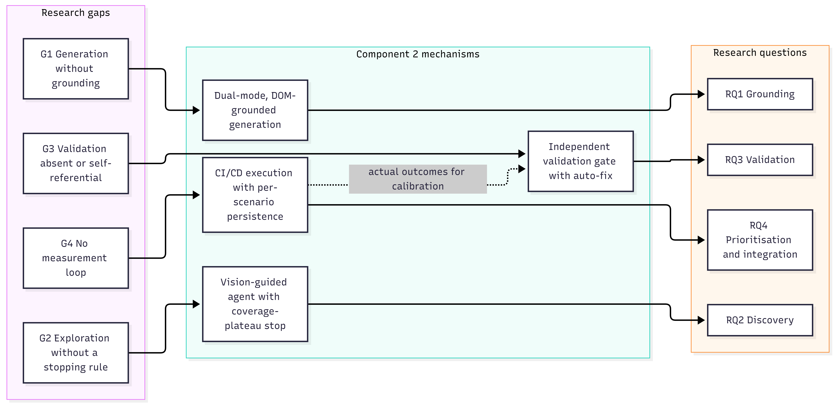
Figure 2.1: Conceptual framework linking research gaps, mechanisms and research questions

RESEARCH METHODOLOGY
This chapter explains how the research was conducted: the Design Science Research design, the materials and data used, the procedures followed, the metrics and analysis, the ethical and responsible-AI measures, and the artefacts that allow the work to be reproduced. It separates what has been measured on the deployed system from the controlled experiments that are specified but still to be run.

Research design
The work followed Design Science Research (DSR) as described by Hevner et al. [21], using the process model of Peffers et al. [22]. DSR suits this problem because the contribution is an artefact, a test generation and validation engine, whose utility must be demonstrated and evaluated in its intended environment. Figure 3.1 maps the six DSR activities to this thesis.

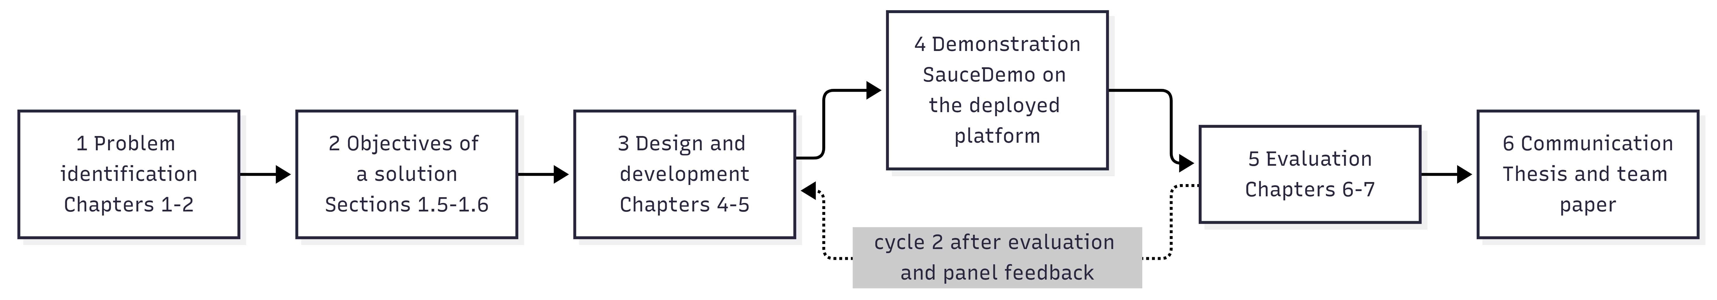Figure 3.1: Design Science Research process applied to Component 2
Two design cycles were completed. The first cycle targeted SauceDemo with fixed flows and established the core path from story to Playwright code. The second cycle generalized the component to any URL and added the agent explorer, the versioned suite editor and CI/CD execution; after panel feedback it also added the independent validation gate.
The evaluation combines three strands. Operational measurement reads real generation and execution records from the production database. Technical evaluation exercises specific mechanisms, such as the validator and the risk model, on stored artefacts and data. Controlled experiments, specified in Section 3.3.6, isolate the effect of single design choices and are required before the research questions can be answered with statistical confidence.

Data participants or study materials
The primary study object is SauceDemo (Swag Labs), a public demonstration e-commerce application published by Sauce Labs for automation practice [25]. It offers login, an inventory page, a cart and a two-step checkout, and it provides built-in user accounts with seeded defects (the standard user alongside the problem, error and visual users). These accounts make controlled fault-detection experiments possible without building a faulty application. Table 3.1 lists the materials used in the evaluation.
Table 3.1: Study materials and evaluated configuration
Material | Description | Used for
SauceDemo benchmark [25] | Public demo web application with login, inventory, cart and two-step checkout; seeded-defect user accounts | Target application for crawling, generation and execution
User stories | 12 user stories in the SauceDemo evaluation project, with acceptance criteria | Input to Gherkin and code generation
Production database | Neon PostgreSQL records of the deployed component: 65 executions and 249 scenario runs | Generation-quality and pass-rate metrics
Stored artefacts | Active Playwright suite v28, Selenium suite v2, Cypress suite v3, and the Gherkin feature “Remove a product from the cart” | Validation gate evaluation
Synthetic risk dataset | 2,000 rows sampled from flow-specific Gaussian priors; label derived from past_pass_rate by thresholds with 5% label noise | Bootstrapping the risk model
LLM configuration | Generator gpt-4o-mini; validator (judge and fixer) gpt-4o; agent vision model gpt-4o | Generation, validation and exploration

Participants. No study with human participants has yet been carried out. Gherkin approvals recorded in the system were made during development within the project team. A practitioner study is planned (Section 3.3.6) and requires informed consent and ethics clearance before it runs.

Experimental or study procedure

Operational evaluation of generation and execution
- Create the SauceDemo project and import or enter the 12 user stories with their acceptance criteria.
- Generate a Gherkin feature per story (template or LLM); a QA engineer edits and approves.
- Probe and crawl the target pages, then review and approve the element map.
- Generate DOM-aware suites for Playwright, Selenium and Cypress.
- Select a suite and execute it locally or through GitHub Actions; every execution and every scenario run is persisted.
- Run the evaluation script over the production database to compute generation-quality metrics and produce the charts.

Validation gate evaluation
- Configure the validator through the VALIDATOR_* environment variables to use gpt-4o, a different model from the gpt-4o-mini generator.
- Validate the active Playwright, Selenium and Cypress suites and one Gherkin feature.
- Record the static score, judge score, per-scenario predictions, final score, verdict, findings and judge duration.
- Request an auto-fix for the fixable findings of the Playwright suite, inspect the diff and change log, apply it as a new version and re-validate with the previous report as parent.
- Query the project summary endpoint for the calibration of predicted against actual pass rate.
An earlier smoke run used gpt-4o-mini as the judge; its behavior is analyzed qualitatively as Finding F3 (Section 6.5).

Risk model training
The synthetic dataset of 2,000 rows was split into 1,600 training rows and 400 test rows. SMOTE was applied to the training data, a random forest was trained, and a decision tree was trained as a baseline, with random_state set to 42 throughout. The classification report, confusion matrix, per-class metrics and feature importance were then produced.

Agent explorer runs
Each run starts from a one-sentence intent, such as “check the login flow”, with the default limits of 12 maximum steps and a plateau limit of 3 steps without a novel state. For each run, the number of steps, unique UI states, discovered scenarios and stop reason are recorded. [State how many runs were logged and the intents used.]

Software verification
The 37 automated unit and integration tests run inside the built container image on every deployment, and the validation routes were exercised over HTTP against the live database before merging (Section 5.4).

Controlled experiments specified for completion
The following experiments complete the evaluation of the research questions. Their designs are fixed; their results are not yet available and are not claimed in Chapter 6.
- Grounding ablation (RQ1). Mode A, Mode B and a naive zero-shot baseline on the same stories, with mean and standard deviation over at least five runs per condition.
- Fault detection (RQ1, RQ4). Run the generated suites against the standard user and the problem, error and visual users, separating generation defects from application defects in the manner of seeded-fault analysis [26].
- Prioritization (RQ4). APFD of the risk-ordered suite against the default order on the seeded faults.
- Exploration (RQ2). The agent against a breadth-first crawler and a random walker at an equal step budget, plus an ablation of reflexion memory.
- Validator calibration (RQ3). Predicted against actual pass rate over a larger set of executed suites, with the judge on the same model as the generator versus a different model.
- External validity. Secondary targets such as the OrangeHRM demo and the-internet test site.
- Practitioner study (SO1). Ratings of Gherkin readability and correctness with inter-rater agreement.

Measures and evaluation metrics
Table 3.2 defines each metric, links it to the research question or sub-objective it serves and states whether it has been measured.

Table 3.2: Evaluation metrics, definitions and measurement status
Metric | Definition | Serves | Status
Story-to-Gherkin coverage | Stories with a generated feature divided by all stories | SO1 | Measured
Gherkin approval rate | Approved features divided by generated features | SO1 | Measured
Pass rate | Passed scenario runs divided by all scenario runs | RQ1, SO3 | Measured
Pass rate by flow | Pass rate grouped by the derived flow name (login, cart, checkout, other) | RQ1 | Measured
Executability | Share of generated tests that are collected and run to completion rather than erroring | RQ1 | Planned (ablation)
Validation score and verdict | Weighted, capped combination of judge, scenario and static scores (Table 4.8) | RQ3, SO6 | Measured
Score before and after fix | Deterministic score of an artefact before and after an applied auto-fix | RQ3 | Partly measured
Calibration error (MAE) | Mean absolute difference between predicted and actual pass rate per suite | RQ3 | Pending final runs
Findings precision | Confirmed findings divided by reported findings | RQ3 | Planned
Validation latency | Wall-clock time of one validation, including the judge call | NFR3 | Measured
Generation latency | Wall-clock time to generate a suite per scenario | NFR3 | Pending measurement
Accuracy, macro-F1, per-class precision, recall and F1 | Standard classification metrics on the held-out test set | RQ4, SO7 | Measured (synthetic data)
APFD | Section 2.2.5 | RQ4, SO7 | Planned
Unique UI states, steps to plateau, discovered scenarios | Distinct state hashes per run; step at which the run stops; scenarios emitted | RQ2, SO4 | Pending logged runs
Practitioner rating | Mean rating of Gherkin quality on a 1 to 5 scale | SO1 | Planned
Calibration error is computed over the N suites that have both a validation report and a finished execution, where the hat value is the predicted pass rate of suite i and the plain value is its actual pass rate:
\mathrm{MAE} = \frac{1}{N} \sum_{i=1}^{N} \left| \hat{p}_i - p_i \right|

Data analysis
Generation-quality metrics are computed by the evaluation script directly from the database. Pass rates are aggregated from the per-scenario test_runs rows, grouped by the flow_name that is derived from each scenario's name at execution time. Because every execution writes one row per scenario, pass rates are computed over scenario runs rather than over executions.
Calibration joins each suite's latest validation report with its latest finished execution and compares the predicted pass rate with the observed one. Risk model performance is analysed with scikit-learn's classification report, confusion matrix and the random forest's impurity-based feature importance, and is compared with the decision-tree baseline.
The validator's findings are also analysed qualitatively: each finding on a stored suite is checked by hand against the code, the Gherkin and the application. The current sample sizes support descriptive statistics only; no inferential claims are made. The controlled experiments of Section 3.3.6 report the mean and standard deviation over repeated runs to account for LLM non-determinism.

Ethics privacy security and responsible AI
Human oversight. Generated Gherkin, suites and fixes are proposals. A human approves Gherkin before code generation, selects the suite to execute and applies each repair; nothing is applied automatically.
Auditability. Every validation report records the provider and model that judged, whether it differed from the generator, the content hash of what it validated and the score breakdown, so automated judgements can be audited later.
Privacy. Screenshots and DOM content of the target application are sent to the configured LLM provider. SauceDemo is a public demonstration site that uses published test credentials and holds no personal data. For sensitive applications, the provider layer supports a local model through Ollama so that no screenshot leaves the organisation.
Security. JSON Web Tokens (JWT) are enforced at the gateway, all traffic uses HTTPS, GitHub personal access tokens are encrypted at rest with Fernet, internal service calls require a shared header key, and secrets are kept out of git and container images.
Honest reporting. The risk model's accuracy is reported as a validation of the pipeline on synthetic data, not as evidence of real-world predictive power, and results still pending are marked as such.
Research ethics. The planned practitioner study will collect informed consent and will not record personal data beyond role and experience. [Insert the SLIIT ethics approval reference if one is obtained.] The use of generative AI in preparing this thesis is disclosed in Appendix B.

Reproducibility and research artefacts
The results in Chapter 6 can be regenerated from the repository with the following commands, run inside the project's virtual environment:
cd Intelligent-Test-Case-Generation/backend
python -m pytest tests # 37 unit and integration tests
python -m app.ml.reports.generation_eval # generation metrics and charts
python -m app.ml.train # risk model training and metrics
python -m app.ml.reports.make_charts # risk model charts

The research artefacts are:
- Source code of the component and its dashboard modules: [insert repository URL or archive reference].
- Deployed service with public OpenAPI documentation at https://nextgenqasliit.duckdns.org/testcase-docs/docs.
- Evaluation outputs: generation_metrics.json, metrics.json and the chart images in backend/app/ml/reports/.
- Configuration and deployment: the environment variables and the deployment workflow in Appendix A.
- Determinism controls: random_state 42 for the risk model; content hashes on suites and validation reports; the judging model recorded in each report.
LLM generations and judgements are not bit-for-bit reproducible, which is why the controlled experiments report repeated runs rather than single outcomes.

PRODUCT AND SOLUTION DESIGN
This chapter presents the design of Component 2 as a product: the requirements it satisfies, its place in the NextGen QA architecture, the design alternatives considered and the decisions taken, the detailed design of each module, and the standards and professional practices followed.

Requirements

Requirement gathering and analysis
Requirements were gathered from three sources: the NextGen QA problem analysis and the interfaces agreed with the owners of Components 1, 3 and 4; a review of QA practice in Agile teams and of the tools QA engineers currently use (Section 2.4); and supervisor and panel feedback across the proposal, progress and final presentations. The panel feedback added the requirement for a mechanism to independently validate generated test cases, which became FR9, FR10 and NFR2. The resulting functional and non-functional requirements are listed in Table 4.1 and Table 4.2.

Functional requirements
Table 4.1: Functional requirements
ID | Requirement
FR1 | Import user stories from Component 1 for the active project and iteration; allow manual entry and bulk upsert
FR2 | Generate a Gherkin feature per story; allow QA to edit, regenerate and approve; only approved Gherkin feeds code generation
FR3 | Probe a target URL and crawl its DOM into an element map with semantic roles and confidence, editable by QA
FR4 | Generate test suites per selected framework in abstract or DOM-aware mode; store each generation as a new version; detect staleness when inputs change
FR5 | Allow QA to edit code in a Monaco editor, save, branch to a new version, restore history and select one suite for execution
FR6 | Execute the selected suite locally or through GitHub Actions; stream logs over WebSocket; capture screenshots; persist per-scenario results; produce a PDF report; support re-run
FR7 | Connect a GitHub repository with an encrypted personal access token and install the workflow file automatically
FR8 | Run an autonomous exploration from a one-sentence intent and stream the agent's reasoning, actions, discovered scenarios and coverage
FR9 | Validate a Gherkin set or a test suite independently; show the predicted pass rate, per-scenario predictions, findings with line references and the score breakdown
FR10 | Propose an LLM repair for selected findings; show a diff; apply it as a new version and re-validate with linkage to the previous report
FR11 | Predict a risk level per flow and show it on the Code Review page
FR12 | Expose failed tests and selectors to Component 3 and traceability to Component 4

Non-functional requirements
Table 4.2: Non-functional requirements
ID | Category | Requirement
NFR1 | Security | JWT enforced at the gateway; HTTPS only; personal access tokens encrypted at rest (Fernet); secrets outside git and images
NFR2 | Independence of validation | The judge must be configurable to a different provider or model from the generator; deterministic checks must run without any model
NFR3 | Performance | Gherkin generation under 10 s per story; code generation for three frameworks in parallel; validation under 20 s per suite
NFR4 | Reliability | Health endpoints; a failing test suite must block deployment; long-running work must not block request handling
NFR5 | Maintainability | One module per pipeline stage; API documented with OpenAPI; schema changes through an idempotent startup migration
NFR6 | Portability | Containerised; LLM provider pluggable (Anthropic, OpenAI, Gemini, Ollama)
NFR7 | Traceability | Every suite records the hash and ids of the scenarios it was generated from; every validation report records the hash of the text it validated

Feasibility study
Technical feasibility. Playwright provides a stable headless browser for both crawling and execution, with native screenshot capture. FastAPI provides asynchronous request handling and WebSockets, scikit-learn is sufficient for the tabular risk model, and GitHub Actions removes the need for a self-managed CI server. The multimodal reasoning required by the agent explorer is available from commercial APIs (GPT-4o and Claude Sonnet). A proof of concept from story to Playwright code against SauceDemo was completed in the first sprint, which confirmed the feasibility of the core path.
Economic feasibility. All infrastructure used free or student tiers: GitHub Actions minutes, the Neon PostgreSQL free tier, an AWS EC2 t3.medium instance on credits, DuckDNS for the domain and Let's Encrypt certificates through Caddy. LLM usage is the only variable cost. It was contained by using a small model (gpt-4o-mini) for high-volume Gherkin and code generation and reserving larger models (gpt-4o and Claude Sonnet) for the vision agent and the validator.
Operational feasibility. QA engineers already review test cases and code, and the dashboard keeps them in that role (approve Gherkin, review code, approve a fix) rather than requiring new skills. SauceDemo is a public, stable benchmark used widely in automation training, and its seeded-defect accounts make controlled fault-detection experiments possible without building a faulty application.
Schedule feasibility. The work ran from April to October 2026 across eight sprints, as summarised in Table 4.3.
Table 4.3: Development schedule by month
Period (2026) | Work completed
April | Foundation and dashboard; persistence and project scoping
May | DOM crawler and dual-mode generation; risk model and agent explorer
June | Versioned suites and GitHub execution; live preview and re-run
July to August | Shared-gateway integration and migration to Neon PostgreSQL
August | AWS deployment and the CI gate
October | Independent validation gate and auto-fix

Component architecture within the complete solution

Platform architecture
NextGen QA is deployed as micro-services behind a single API gateway (Figure 4.1). The browser talks only to the gateway, which verifies JWTs issued by the authentication service and forwards requests by path prefix: /api/test-case goes to Component 2 on port 8002, with WebSocket pass-through. Each service owns a database on Neon PostgreSQL. The authentication service is the system of record for organisations, projects and iterations, and the other services store only reference UUIDs. Component 2 therefore accepts a client-supplied project UUID so that its project rows share identity with the platform project.
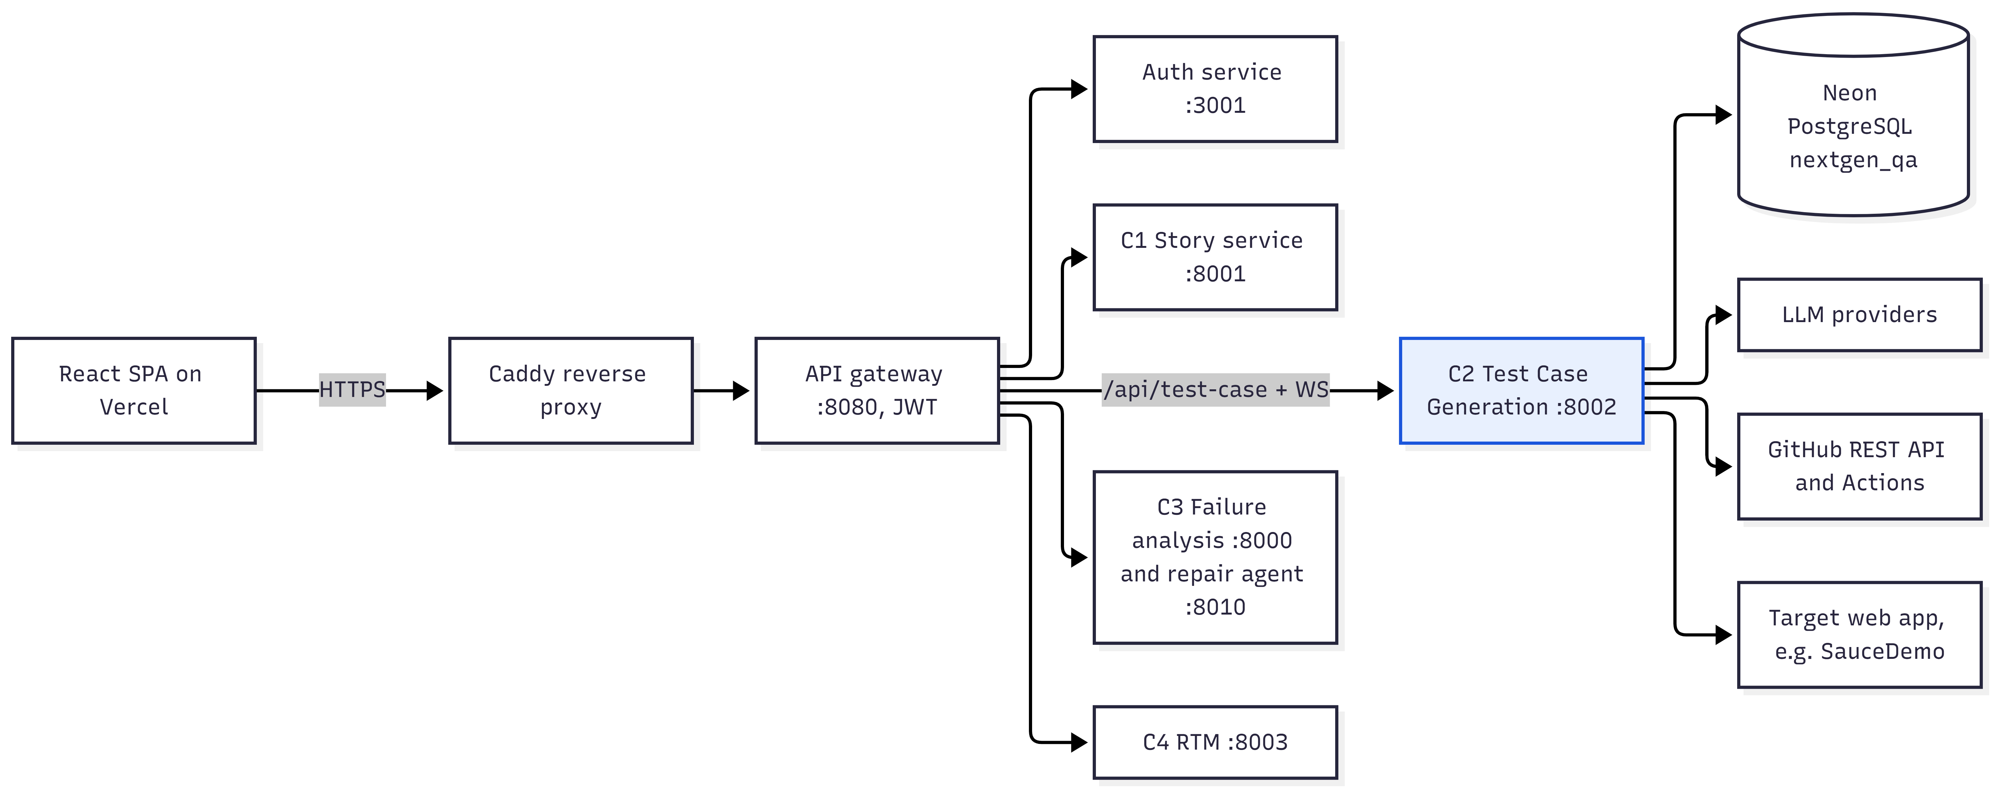Figure 4.1: NextGen QA deployment architecture

Component pipeline
Component 2 is organised as six stages, each implemented as a backend package with a matching dashboard screen (Figure 4.2):
- User story intake — import from Component 1 or manual entry.
- Gherkin generation and approval — template-first with LLM fallback; QA edits and approves; independent validation is available.
- Mode setup and DOM inspection — choose abstract or DOM-aware mode, frameworks and target URL; probe and crawl; edit and approve the element map. The agent explorer sits beside this stage as the autonomous discovery path.
- Code generation and review — one LLM call per framework in parallel; sanitizer; versioned suites; stale detection; independent validation and auto-fix; risk badges.
- Execution — local Playwright runner or GitHub Actions; live logs; screenshots; PDF report; per-scenario persistence.
- Downstream — failed tests and selectors to Component 3; traceability to Component 4; execution results feed validator calibration and the risk model.
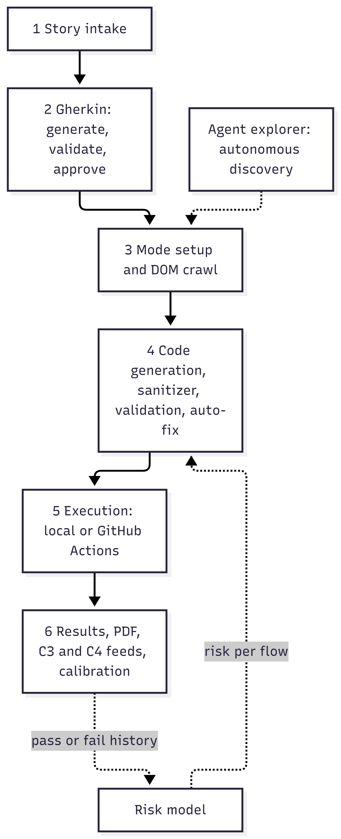
Figure 4.2: Component 2 six-stage pipeline

Use cases
Figure 4.3 shows the actors and use cases of the component. The QA engineer is the primary actor and drives every stage; the developer connects the GitHub repository; and the services of Components 1, 3 and 4 act as system actors that supply stories or consume results.
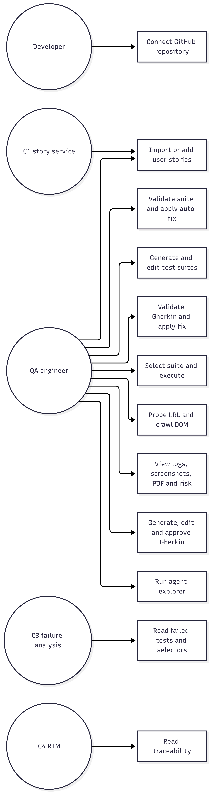
Figure 4.2: Component 2 six-stage pipeline

Design alternatives and decisions
Each major design choice was made between explicit alternatives. Table 4.4 records the decision, the alternatives considered and the rationale, so that the design can be challenged and revisited as evidence accumulates.
Table 4.4: Design alternatives and decisions
Decision | Alternatives considered | Choice | Rationale
Gherkin generation strategy | LLM only; templates only | Template-first with LLM fallback and QA approval | Templates guarantee structure for frequent flows; the LLM handles novel flows; a human approves before downstream use
Locator source | Placeholders only; recorded locators | Two modes: abstract (Mode A) and DOM-aware (Mode B) | Mode B grounds selectors in the crawled DOM; Mode A stays portable without staging access and serves as the ablation baseline
Framework fan-out | Sequential calls; one combined call | One LLM call per framework, run concurrently | Wall-clock time becomes the slowest call rather than the sum
Recurring code anti-patterns | Prompt wording only | Deterministic sanitizer after every generation and fix | Prompt guidance is probabilistic; the same patterns recur regardless of wording
Agent reasoning structure | Four separate agents and calls | Four role-tagged thoughts and one action in a single JSON response | The structure of a multi-agent loop without four times the token cost
Agent termination | Fixed step budget only; agent decides only | Coverage plateau on novel state hashes, plus agent stop and step limit | Gives exploration a coverage-based stopping rule
Validation independence | Generator judges itself; static checks only | Static checks plus a judge pinned to a different model | Avoids self-enhancement bias [19]; deterministic verdicts do not depend on any model
Judge failure | Fail the validation | Fall back to a static-only score with an informational finding | Validation stays available when a provider fails
Fixer output format | Code encoded in JSON | Code between explicit markers, followed by a JSON change log | Keeps large code bodies intact
Staleness detection | Timestamps | SHA-256 content hashes of inputs and validated text | Detects real changes regardless of when an edit happened
Schema evolution | A dedicated migration tool | Idempotent startup migration | A fresh database boots in one step with no extra tooling
Risk model | No model; more complex learners | Random forest with SMOTE and a decision-tree baseline | Robust on small tabular data and explains itself through feature importance [17], [18]
CI execution | Self-managed CI server | GitHub Actions with one branch per run, plus a local runner | No CI server to maintain; the run branch isolates generated code from the main branch

Three of these decisions carry the research questions. The two generation modes make the grounding effect measurable (RQ1). The plateau criterion turns an agent that completes tasks into one that knows when discovery is complete (RQ2). And pinning the judge to a different model, behind deterministic checks, is what makes the validation gate independent (RQ3).

Detailed design
This section details each module in pipeline order. Sequence and flow diagrams show the interactions that matter for the research questions: story to suite (Figure 4.4), one agent iteration (Figure 4.5), agent termination (Figure 4.6), score composition (Figure 4.7) and the validate-fix-revalidate loop (Figure 4.8).

User story intake
Stories are scoped to a project and optionally to an iteration. The merged dashboard's “Import from Meetings” action fetches approved stories from Component 1 through the gateway, maps MoSCoW priorities to high, medium and low, and maps the ‘As a / I want / so that’ structure to actor, action and goal. It then bulk-upserts the stories into Component 2, keeping the Component 1 UUID as the story id, so repeated imports are idempotent and traceability back to the meeting is preserved. Manual entry, with acceptance criteria stored as a JSON array, is supported for projects that do not use Component 1.

Gherkin scenario generator
The generator is template-first. A keyword detector classifies the story as login, cart, checkout, search or generic and renders the matching Jinja2 template with the story fields and acceptance criteria. When an LLM provider is configured, generate_with_llm produces the feature instead, under a scenario policy: “lean” keeps the happy path and the principal negative path, and “full” keeps all scenarios.
SauceDemo-specific stabilisers normalise known pitfalls, such as the exact invalid-login error text, the behaviour of the cart badge when the cart is empty and the two-step checkout, so that generated Gherkin states observable outcomes. Each feature is stored with its generator (jinja2 or llm), the model used and flags for QA edits and approval. Only approved features reach code generation.

DOM crawler and element map
probe_url checks reachability and detects whether the page requires authentication. crawl_url launches headless Chromium, replays an authentication plan when one is provided (background credentials, manual steps or a stored storage state), waits for network idle and extracts interactive elements (inputs, buttons, links, selects and text areas) with their tag, text, attributes and a stable CSS selector.
_infer_role assigns each element a semantic role, such as password_input, login_button or add_backpack, with a confidence score derived from tag, type and attribute heuristics. Elements are stored per project and URL. QA can edit roles and selectors, add missing elements and approve them, and the crawl log streams live to the dashboard over WebSocket.

Dual-mode multi-framework code generator
The generator works in two modes that differ only in where locators come from (Table 4.5). The difference between them is the independent variable of RQ1.
Table 4.5: Generation modes
Property | Mode A — Abstract | Mode B — DOM-aware
Inputs | Approved Gherkin | Approved Gherkin and the crawled element map for the URL
Locators | Placeholders such as <<USERNAME_INPUT_PLACEHOLDER>> | Exact crawled selectors; a TODO comment where a step needs an element that was not crawled
Runnable immediately | No | Yes
Use | No staging access; portability demonstration; ablation baseline | Live staging; the demonstrated path

The prompt is assembled from five parts: framework instructions (Python with pytest and Playwright, Python with pytest and Selenium, or JavaScript with Cypress); runtime constraints (headless only); target-application knowledge for SauceDemo (the URL after login, exact error strings, add-to-cart buttons that toggle, the two-step checkout and reference helper implementations); test design rules (no test calls another test, helpers for shared steps, a fresh page per test, robust selectors); and strict scope rules (implement only the listed scenario titles).
All selected frameworks are generated concurrently with asyncio.gather, so wall-clock time is that of the slowest call rather than the sum. Markdown fences are stripped and the result is sanitised. Suites are versioned per project and framework: each generation deactivates the current head and inserts version n+1, and each suite stores the combined hash of its scenario ids and DOM inputs so that the list endpoint can flag stale suites. Figure 4.4 shows the full path from story to executable suite.
Figure 4.4: Sequence diagram: story to executable suite

Deterministic sanitizer
Prompt guidance is probabilistic; the sanitizer is not. It runs after every generation and after every auto-fix, and mechanically repairs patterns that LLMs reintroduce regardless of prompt wording. The clearest example is clicking the same #add-to-cart-* selector twice: on SauceDemo the button toggles to #remove-* after the first click, so the second click waits until it times out. The sanitizer applies only repairs that cannot change the meaning of otherwise-correct code, and returns the list of applied fixes for logging and for the validation report.

Vision-guided agent explorer
The agent turns a one-sentence intent, such as “check the login flow”, into autonomous exploration. Each iteration (Figure 4.5) performs the following steps:
- Wait for the page to settle, inject the Set-of-Mark overlay and collect the numbered element list.
- Take a screenshot, compute the state hash and decide whether the state is novel.
- Call the vision model with the intent, the sub-goals done and pending, the action history, the reflexion lessons, the element list and the screenshot.
- Parse the JSON response, which contains four role-tagged thoughts (planner, actor, observer, critic) and one action: click, fill, select, navigate, discover_scenario, complete_goal or stop.
- Execute the action with Playwright, record the step and any lesson, and publish typed events (status, screenshot, thought, action, scenario_discovered, lesson, coverage, done, error) to the per-run broker that the dashboard consumes over WebSocket.
The overlay is a JavaScript snippet that draws numbered boxes over interactable elements and returns their selectors and bounding boxes. A UI state is identified by the SHA-1 hash of the URL together with the sorted element fingerprints, so novelty is a simple set-membership test. Lessons that the critic emits after failed actions are appended to the reflexion memory and injected into later prompts.
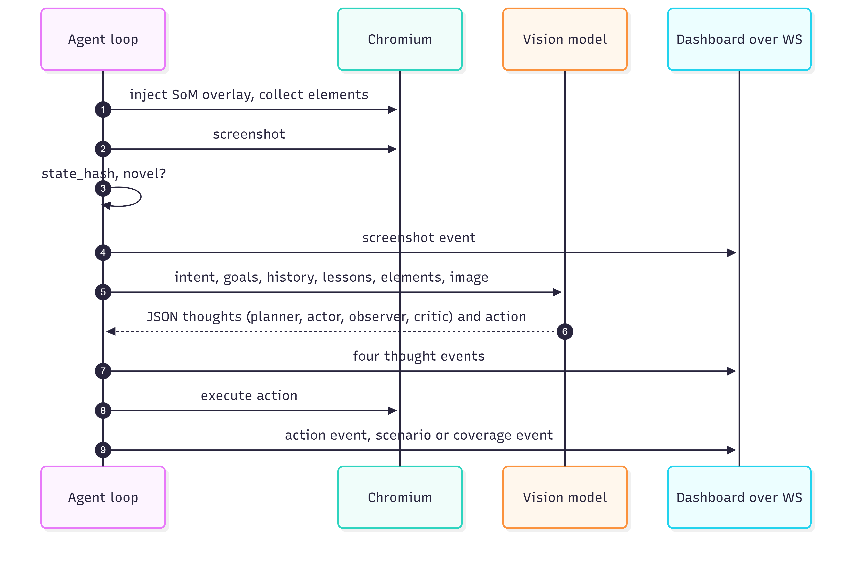Figure 4.5: Sequence diagram: one agent-explorer iteration

Termination is the research contribution of this module (Figure 4.6). The loop stops when the agent emits stop, when max_steps (default 12) is reached, or when PLATEAU_LIMIT consecutive steps (default 3) add no novel state. At the end, a synthesis call converts the discovered states and actions into Gherkin scenario drafts, which the QA engineer can approve into the normal pipeline.
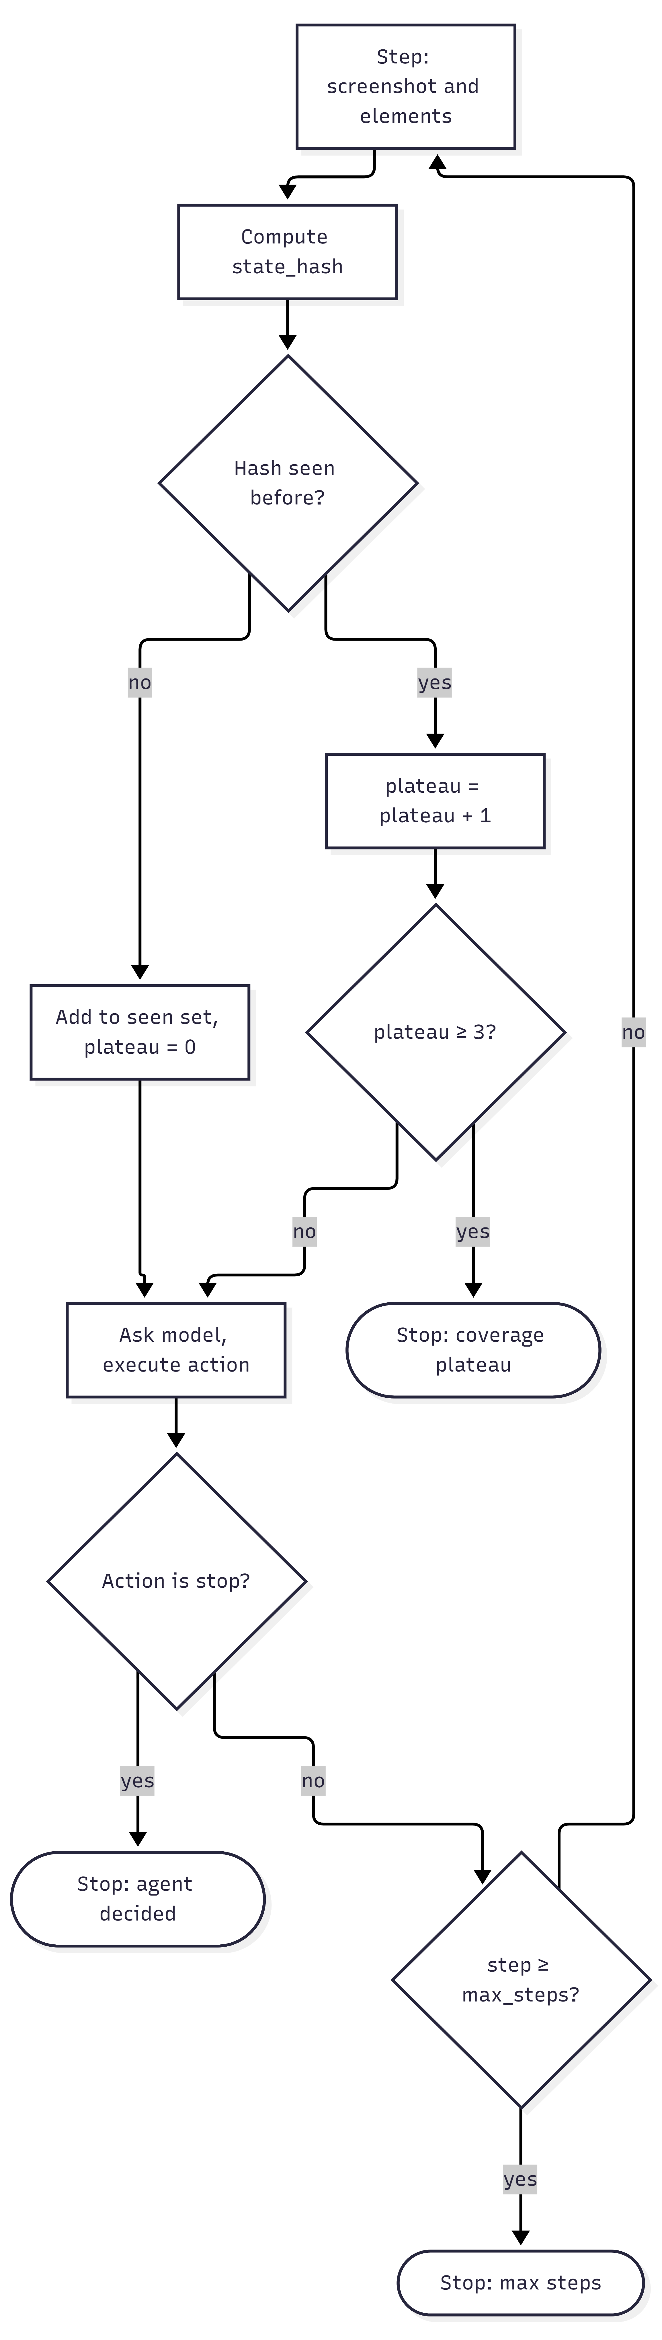
Figure 4.6: Coverage-plateau termination flow

Execution engine
detect_mode chooses GitHub execution when the project has a connected repository and credentials, and the local runner otherwise.
The local runner writes the selected suite into a temporary pytest project with an instrumented conftest.py. The configuration forces a headless launch, snapshots a live frame after each action for the dashboard preview and takes a final screenshot per test. The runner parses the pytest summary into passed and failed counts and per-test status.
The GitHub runner pushes the suite to a runs/{uuid} branch, dispatches the installed workflow, polls run progress, fetches the final log through the REST API and reads the per-scenario results. The branch per execution isolates generated code from the team's main branch.
Both paths write one test_run_executions row per execution and one test_runs row per scenario, with a derived flow_name used by the risk model. Both stream progress over WebSocket, store screenshots, generate a PDF report and support re-run. The GitHub connection module validates a personal access token, lists repositories, stores the token encrypted with Fernet under a persistent key, and installs the workflow YAML into the repository on connection, with an option to reinstall it.

Independent validation gate
Panel feedback required a mechanism to independently validate the generated test cases. Independence is achieved by combining four checks whose correctness does not depend on the generator:
- Deterministic static checks (Table 4.6 and Table 4.7) are pure functions of the artefact text, the element map and the source Gherkin, and are unit-tested without network access.
- An LLM judge that did not author the artefact is pinned to a different model through configuration. It receives the line-numbered artefact, the Gherkin, the element map marked explicitly as partial, known facts about the target application, and the static findings already discovered so that it does not repeat them. It returns strict JSON: a holistic pass probability; a per-scenario prediction of pass, fail or uncertain with confidence and reason; findings with severity, category, line, snippet, suggestion and a fixable flag; and strengths. For Gherkin it also returns semantic acceptance-criteria coverage. The prompt (Appendix A) defines the severity scale: critical means the file will not be collected or one root cause fails most tests; major means one test fails or is vacuous; minor means fragile or unverified; info is an observation.
- Execution calibration joins each suite's latest report with its latest finished execution to compare predicted and actual pass rates and compute the mean absolute error.
- Human review shows findings, predictions and diffs before approval; nothing is applied automatically.
Table 4.6: Deterministic checks for test suites
Check | Severity | Rationale
Python ast.parse; JavaScript bracket and string scanner; node --check when available | Critical | The file will not be collected; every test fails
No test_* function or it(...) block found | Critical | The runner collects zero tests
Unresolved <<PLACEHOLDER>> in DOM-aware mode (info in abstract mode) | Critical | Not a valid selector
Test with no assertion (direct, expect, .should, explicit wait, or through a helper that asserts, resolved transitively) | Major | Vacuous: cannot fail on a defect
Empty test body | Major | Passes trivially
Test calls another test | Major | Fixtures are not injected; raises TypeError
Gherkin scenario with no implementing test (title matched on name, docstring and body) | Major | Requirement silently dropped
Headed browser forced | Major | Crashes on CI without a display
Known fatal anti-pattern (sanitizer dry run) | Major | Hangs until timeout
Selectors not in the crawled element map (one grouped finding with the nearest crawled candidates) | Minor | Unverified: uncrawled page or invented
Long fixed sleeps, long cy.wait, leftover TODO | Minor | Flakiness or incompleteness

Table 4.7: Deterministic checks for Gherkin Scoring.
Check | Severity
Empty text; no scenarios; empty scenario | Critical
Missing Feature: header; scenario without When; scenario without Then; Scenario Outline without Examples; placeholder without a matching column | Major
Missing Given; scenario starts with And or But; duplicate titles; untitled scenario; vague wording such as “works correctly”; acceptance criterion not lexically covered | Minor

The score is deliberately simple and is stored with each report so that the dashboard can explain it (Table 4.8 and Figure 4.7). With n_crit, n_maj and n_min the numbers of critical, major and minor static findings, the static score and the base score are:
s_{\mathrm{static}} = \max\left(0,\; 100 - 25\,n_{\mathrm{crit}} - 10\,n_{\mathrm{maj}} - 3\,n_{\mathrm{min}}\right)

s_{\mathrm{base}} = 0.5\,s_{\mathrm{llm}} + 0.3\,s_{\mathrm{scen}} + 0.2\,s_{\mathrm{static}}, \qquad s = \min\left(s_{\mathrm{base}},\, c\right)
Here s_llm is the judge's pass probability, s_scen is the scenario pass rate predicted by the judge, and c is the lowest cap that applies (100 when none does).
Table 4.8: Validation score rules
Term | Definition
static_score | 100 minus penalties (critical 25, major 10, minor 3), floored at 0
llm_score | The judge's pass probability (0 to 100)
scenario_rate | Scenarios predicted to pass divided by scenarios judged, times 100
base | 0.5 × llm_score + 0.3 × scenario_rate + 0.2 × static_score; static_score alone when no judge is available
caps | Any static critical: at most 15; any judge critical: at most 40; any major: at most 85
verdict | likely_failing if any critical or a score below 50; ready if the score is at least 80 with no major; otherwise needs_review

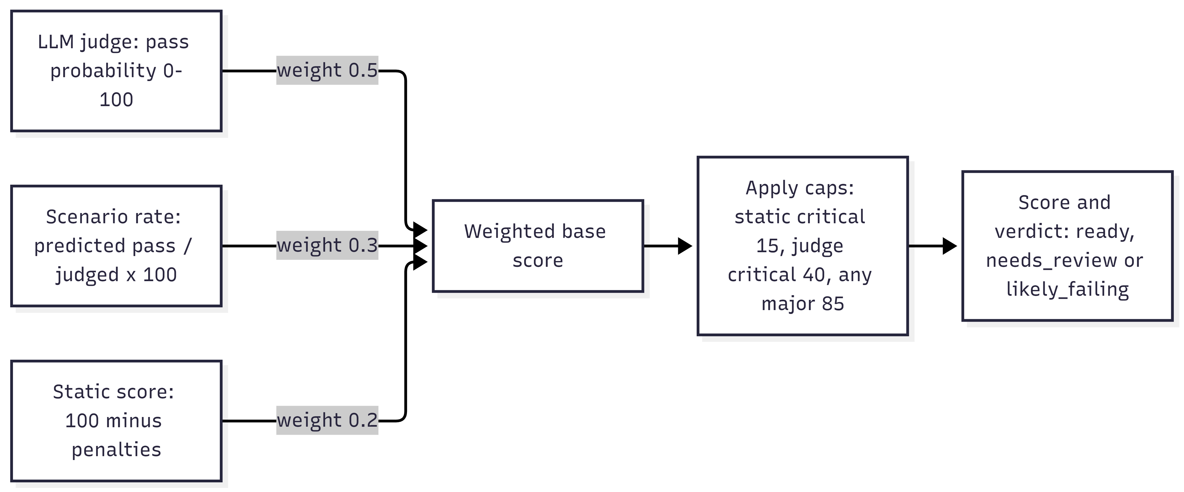
Figure 4.7: Validation score composition
The caps encode a simple principle: a deterministic defect that guarantees failure cannot be outvoted by an optimistic judge. Each validation_reports row stores the target type and id, the content hash of the validated text, the scores, verdict, findings, scenarios and breakdown (weights, caps applied, counts, and whether the judge was available and independent), the judge provider and model, the duration and an optional parent report id. The dashboard marks a report as outdated when the stored hash no longer matches the current text.

LLM auto-fix loop
The fixer receives the artefact, the selected findings (ids, lines and suggestions), the Gherkin, the element map marked as partial and the framework rules. It must return the minimally changed artefact between explicit markers, followed by a JSON change log that maps each edit to a finding id; marker delimiting rather than JSON encoding keeps large code bodies intact. The sanitizer then runs on the result, and the static checks run again to report the deterministic score before and after the fix.
The proposal is returned to the dashboard, which shows a side-by-side Monaco diff, the change log and the remaining findings. Applying it creates a new suite version (or updates the Gherkin text) and triggers re-validation with parent_report_id set to the previous report, so the movement of the score is recorded (Figure 4.8). Findings marked as not fixable, for example a TODO that needs an uncrawled selector, are excluded from the fixer's scope.
Figure 4.8: Sequence diagram: validate, auto-fix and re-validate

ML risk prediction
The risk model is a three-class random forest (LOW, MEDIUM, HIGH) over an 18-feature schema defined once in features.py, so that training and inference cannot drift (Table 4.9). At inference, the features are extracted from the live database per flow bucket (login_flow, cart_ops, checkout, search) and the prediction is shown on the Code Review page.
Because no execution history exists on day one, the training set of 2,000 rows is synthesised from bucket-specific Gaussian priors, with the label derived from past_pass_rate by thresholds and 5% label noise. The dataset script is designed to be replaced by a real-data extractor with the same CSV schema once enough test_runs rows accumulate. This provenance is stated wherever the model's accuracy is reported.
Table 4.9: Risk model feature schema
Group | Features
Priority (one-hot) | priority_high, priority_medium, priority_low
Scenario shape | n_steps, has_auth, has_payment, has_form_input
DOM and UI | n_inputs, n_buttons, avg_dom_confidence
Authoring | qa_edit_ratio, n_assertions, n_waits, code_lines
Execution history | past_pass_rate, past_runs, mean_duration_s, duration_stddev_s

Reporting and traceability
A PDF report is generated per execution with the summary, per-scenario outcomes and screenshots. Read-only integration endpoints serve Component 3 (failed scenarios and the element map) and Component 4 (traceability from story to execution), and a validation summary endpoint exposes counts, the average score and the predicted-versus-actual calibration. Their interfaces are described in Section 5.3.

Standards and professional practice
The design follows established standards and professional practices wherever one applies.
- Specification. Scenarios use the Gherkin syntax defined by Cucumber [2], so generated features can be read by non-programmers and executed by standard BDD tooling.
- API design and documentation. The service exposes a versioned REST API under /api/v1 and WebSocket channels, documented automatically in the OpenAPI format and served at /docs and publicly at /testcase-docs/docs.
- Security. Bearer JWTs are verified at the gateway; TLS certificates are issued by Let's Encrypt and renewed automatically by Caddy; personal access tokens are encrypted with Fernet; internal endpoints require a shared header key; only the reverse proxy is exposed publicly; and secrets are kept in environment files that are excluded from git and from container images.
- Quality assurance of the component itself. Automated unit and integration tests run inside the built image and block deployment on failure; tests are not baked into the production image; and design decisions are recorded with their alternatives (Table 4.4).
- Maintainability. One package per pipeline stage, a single feature schema shared by training and inference, idempotent startup migrations and containerised deployment.
- Traceability and auditability. Content hashes link suites to the scenarios they implement and reports to the text they validated, and each report records the judging model.
- Responsible use of AI. Every generated artefact passes through human approval, model choices are configurable and recorded, and AI assistance in writing this thesis is disclosed (Appendix B).
Referencing. Sources are cited in IEEE style, as recommended by the SLIIT guidelines.

IMPLEMENTATION INTEGRATION AND TESTING
This chapter describes how the design was built: the technology stack, the implementation of the backend packages, data model and API, the integration with the rest of NextGen QA, the verification strategy and test cases, and the deployment and operation of the service.

Development environment and technology stack
The backend was developed in Python inside a project virtual environment, with Node.js available for the Cypress suites and for node --check syntax validation of generated JavaScript. The dashboard modules were developed in the merged team frontend with Vite. Deployment uses Docker images run with Docker Compose. Table 5.1 lists the stack by layer.
Table 5.1: Technology stack
Layer | Technology | Role
Backend | Python 3.10+, FastAPI, Uvicorn, SQLAlchemy 2 (async), asyncpg | REST and WebSocket API, ORM
Browser automation | Playwright (Chromium) | DOM crawler, agent explorer, local test runner, screenshots
Generation | Jinja2 templates; HTTP clients for the Anthropic Messages API, OpenAI Chat Completions, Google Gemini and Ollama | Gherkin and code generation; judge and fixer
Validation | Python ast, a custom JavaScript bracket scanner, node --check when available, difflib | Deterministic checks and diffs
Machine learning | scikit-learn RandomForest, imbalanced-learn SMOTE, joblib | Risk model
Execution | pytest, pytest-playwright, Selenium, Cypress, allure-pytest, GitHub Actions REST API | Running generated suites
Reporting | ReportLab | PDF reports
Security | cryptography (Fernet) | Encrypted token storage
Frontend | React 19, Vite, Tailwind CSS 4, react-router 7, zustand, Monaco Editor (editor and DiffEditor), lucide-react | Dashboard
Data | PostgreSQL 15 on Neon, with JSONB for findings, artefacts and element attributes | Persistence
Deployment | Docker, Docker Compose, Caddy (automatic HTTPS), AWS EC2 (ap-southeast-1), DuckDNS, GitHub Actions self-hosted runner, Vercel | Hosting and CI/CD
Testing | pytest, FastAPI TestClient | Unit and integration tests

Component implementation

Project structure
The backend is a single FastAPI application with one package per pipeline stage (Table 5.2).
Table 5.2: Backend package structure (backend/app/)
Package | Responsibility
main.py | FastAPI app, CORS, lifespan (startup migration), router and WebSocket registration
database.py | Async engine for Neon (SSL, pool pre-ping and recycle); idempotent init_db migration
models.py | ORM models: projects, user_stories, gherkin_scenarios, test_suites, dom_elements, test_runs, test_run_executions, test_run_screenshots, validation_reports
routes.py | Projects, stories, Gherkin, DOM, code suites (versioning) and risk endpoints
gherkin/ | Template detection, Jinja2 templates (login, cart, checkout, search, generic), LLM fallback, scenario policy
dom_crawler/ | Probe, authentication plan, crawler, role inference, log broker
code_gen/ | Prompt assembly, provider calls and the sanitizer
agent_explorer/ | SoM overlay script, agent loop, event broker, routes and WebSocket
execution/ | Mode detection, local runner, GitHub runner, PDF generator, routes and WebSocket
github_connection/ | Token encryption and store, workflow installer, routes
validation/ | Findings model, static checks, LLM client, judge, fixer, service (scoring, persistence, calibration), routes
ml/ | Feature schema, synthetic dataset, training, prediction, report scripts and charts
integration/ | Read-only endpoints for Component 3

The dashboard lives in the merged team frontend under two modules owned by this component: Test Case Gen (/test-case/*: stories, Gherkin editor and agent explorer) and Test Script Gen (/test-script/*: mode setup, DOM inspector, code review, suite editor, execution and GitHub settings). Both share one API module, one types file and a components folder that holds the validation panel, the fix dialog and the score ring.

Data model and startup migration
The schema has nine tables (Table 5.3); their relationships are shown in Figure 5.1. JSONB columns hold variable-shape data such as element attributes, findings and run artefacts.
Table 5.3: Database tables
Table | Purpose | Key columns
projects | Workspace; id shared with the platform project | organization_id
user_stories | Stories per project (composite key with project) | actor, action, goal, priority, status, source, acceptance_criteria, iteration_id
gherkin_scenarios | Feature text per story | generator, llm_model, edited_by_qa, approved
dom_elements | Crawled element map per URL | selector, tag, text, attributes (JSONB), role, confidence, approved
test_suites | Versioned generated code per framework | mode, url, source_scenarios_hash, source_scenario_ids (JSONB), version, is_active, selected_for_run
test_run_executions | One row per execution | mode (github or local), status, github_run_id, github_run_url, github_branch, counts, raw_log_text, artifacts_json, pdf_path
test_runs | One row per scenario per execution | scenario_name, flow_name, status, duration_ms, error_message, execution_id
test_run_screenshots | Screenshot index per scenario | filename, status
validation_reports | Independent validation passes | target_type, target_id, content_hash, score, verdict, static_score, llm_score, scenario_total, scenario_pass_predicted, findings, scenarios and breakdown (JSONB), validator_provider, validator_model, parent_report_id

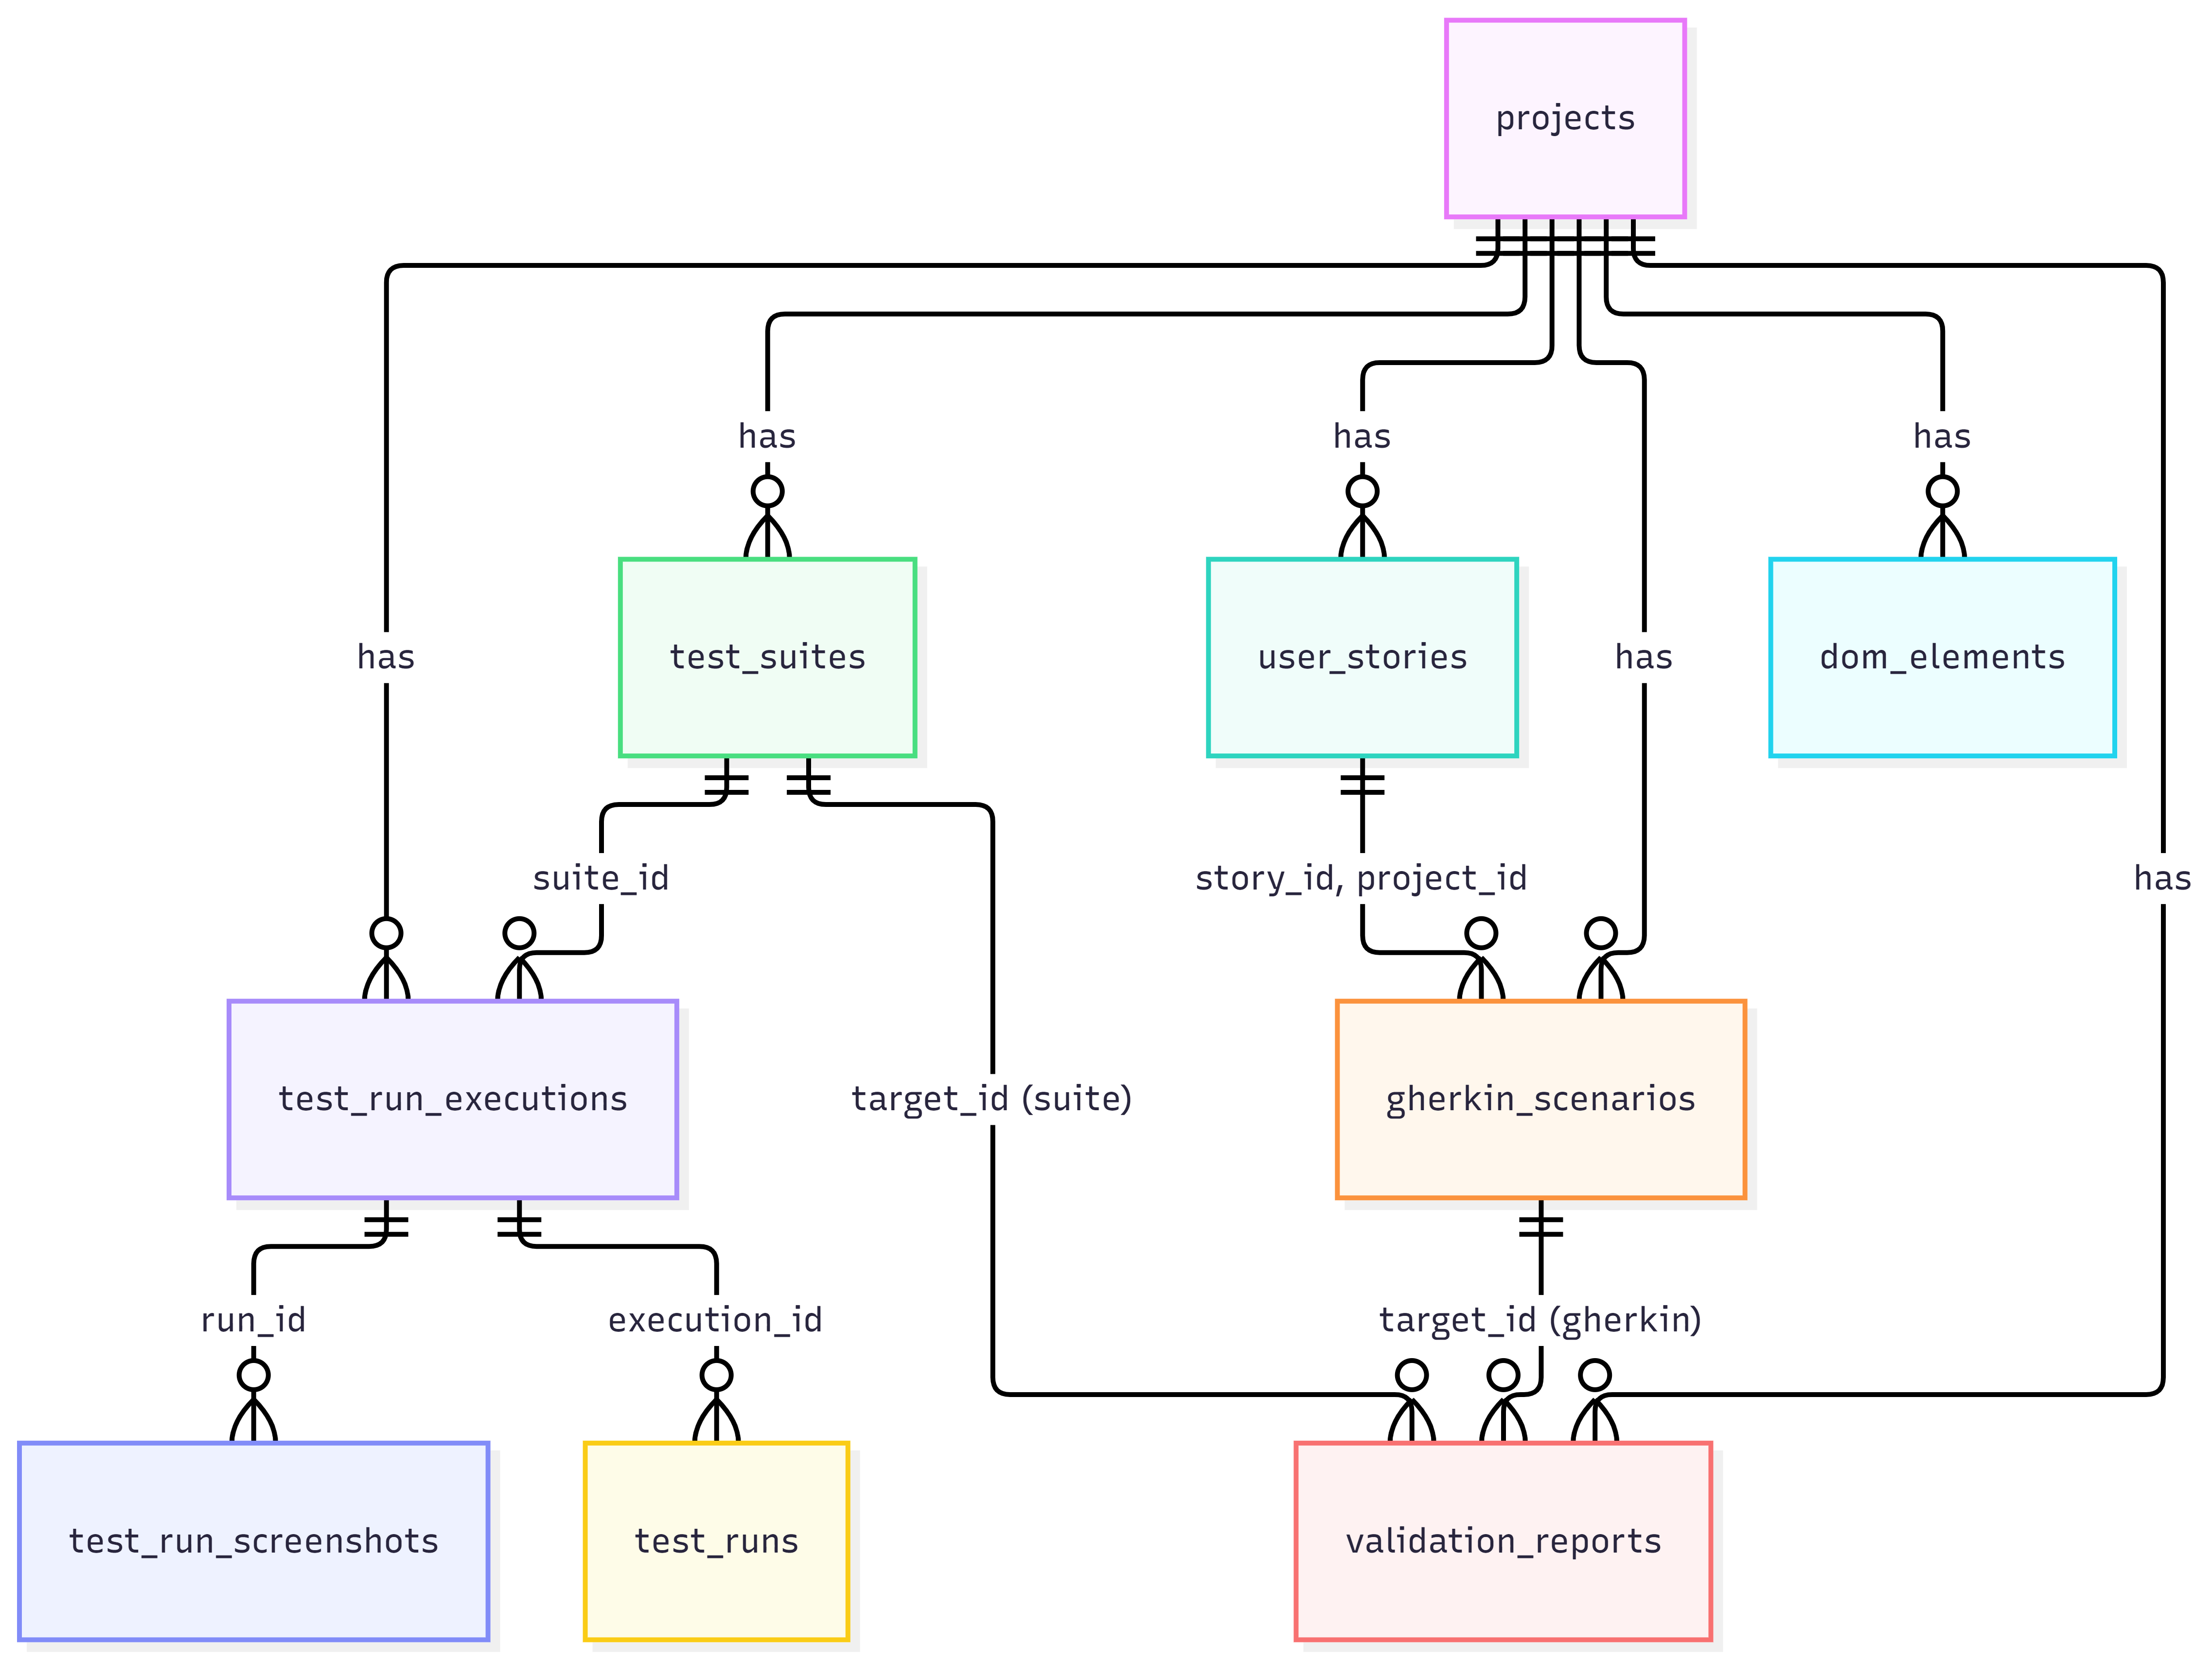
Figure 5.1: Entity relationship diagram of the Component 2 schema
Schema evolution is handled by an idempotent startup migration. create_all creates any missing tables, and a sequence of ADD COLUMN IF NOT EXISTS, index and data-repair statements then patches legacy databases. No migration tool is required, and a fresh Neon database boots in one step.

REST and WebSocket API
All endpoints are under /api/v1 and grouped by pipeline stage (Table 5.4). WebSocket channels stream crawl logs, execution events (log line, status, screenshot frame, finished) and agent events. OpenAPI documentation is served at /docs and publicly at /testcase-docs/docs on the deployment.
Table 5.4: REST endpoints (all under /api/v1)
Group | Endpoints
Projects and stories | POST/GET/DELETE /projects, GET/POST /projects/{id}/stories, POST .../stories/bulk, DELETE .../stories/{sid}
Gherkin | POST /gherkin/generate, GET /gherkin/{pid}/{sid}, PUT /gherkin/{id}, PUT /gherkin/{id}/approve, POST /gherkin/{pid}/{sid}/regenerate
DOM | POST /dom/probe, POST /dom/crawl, GET/POST /dom/elements, PUT/DELETE /dom/elements/{id}, POST /dom/elements/bulk-approve
Code suites | POST /code/generate, GET /code/suites, GET /code/suites/{id}, GET .../history, PUT /code/suites/{id}, POST .../save-as-new-version, POST .../restore, POST .../select-for-run
Execution | POST /execute, POST /runs/{id}/rerun, GET /runs, GET /runs/{id}, GET .../log, GET .../report.pdf, GET .../screenshots/{file}, POST /webhooks/github-runs
GitHub | Validate token, get, connect and disconnect connection, reinstall workflow, ping
Agent | POST /agent/explore
Validation | POST/GET /validation/suites/{id}, POST /validation/suites/{id}/fix, POST/GET /validation/gherkin/{id}, POST /validation/gherkin/{id}/fix, GET /validation/projects/{id}/latest, GET /validation/projects/{id}/summary, GET /validation/reports/{id}
Risk and integration | GET /projects/{id}/risk, GET /projects/{id}/failed-tests, GET /projects/{id}/selectors, GET /projects/{id}/traceability

Code generation and versioning flow
POST /code/generate loads the approved Gherkin, computes the scenario fingerprint, loads the element map for the URL in DOM-aware mode, computes the combined input hash, fans out generation per framework, sanitises each result, deactivates the previous active suite per framework and inserts the new version. The list endpoint recomputes the current combined hash and marks a suite is_stale when it differs from the stored one.
Editing autosaves into the active head. “Save as new version” and “restore” create a new head from the editor text or from a historical row, and “select for run” marks exactly one suite per project. Figure 5.2 shows a version chain from the evaluation, including the validation reports linked through parent_report_id.
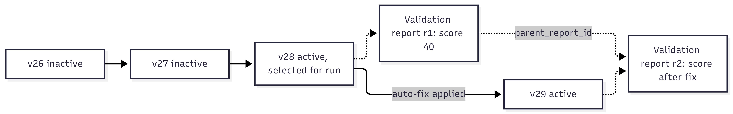
Figure 5.2: Suite version chain and validation report linkage (Playwright framework)

Validation engine internals
static_checks.py contains a small Gherkin parser (feature, background, scenarios, steps and examples) and test extraction for Python, using ast with end lines and docstrings, and for JavaScript, using string-aware brace matching. It extracts selectors for Playwright, Selenium By.* and Cypress cy.get, plus a quote-safe pattern for CSS literals, and grounds them against the element map by exact selector, id, data-test attributes and classes. Assertion detection is helper-aware: a test that asserts only through a helper, or through a helper that calls another asserting helper, is not reported as vacuous.
judge.py and fixer.py build the prompts described in Sections 4.4.8 and 4.4.9 and normalise the responses by clamping severities, validating line ranges and enforcing length limits. service.py loads the context of a suite (the Gherkin it was generated from, falling back to the approved Gherkin, and the element map), orchestrates the checks and the judge, computes the score and persists the report. If the judge fails, the service falls back to a static-only score and adds an informational finding.
The judge model is resolved from VALIDATOR_PROVIDER, VALIDATOR_MODEL and VALIDATOR_API_KEY, falling back to the generator's settings only when these are unset. In the evaluated configuration the generator was gpt-4o-mini and the validator gpt-4o (Appendix A).

GitHub Actions runner and workflow installation
When a repository is connected, the backend writes a workflow file into it through the GitHub Contents API. Each run dispatches that workflow with the run branch and inputs; the workflow installs Python, Playwright and the browser, runs pytest with Allure results and screenshot capture, uploads the artefacts and reports completion. The backend polls the run, streams its status to the dashboard, fetches the final log and parses the per-test outcomes.

Integration with the other components
Component 2 integrates with the platform and with the other three components through the shared gateway and a small set of read-only interfaces (Figure 5.3 and Table 5.5). The read-only design means that no other component can change Component 2's data, and Component 2 never needs to know how its consumers use the data.
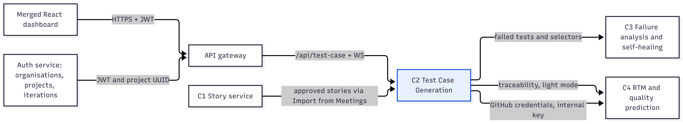
Figure 5.3: Integration of Component 2 with the platform and Components 1, 3 and 4
Table 5.5: Integration interfaces with the other components
Partner | Interface | Content
Gateway and authentication service | Requests under /api/test-case with JWT verified at the gateway; WebSocket pass-through | Client-supplied project UUID shared with the platform project
Component 1 | Dashboard “Import from Meetings”, then POST /projects/{id}/stories/bulk | Approved stories with MoSCoW priority mapped and the C1 UUID kept as story id
Component 3 | GET /projects/{id}/failed-tests | Failed and errored scenario rows: test name, duration, heuristic failure type, extracted old locator, source and suite metadata
Component 3 | GET /projects/{id}/selectors | The element map, as locator-healing ground truth
Component 4 | GET /projects/{id}/traceability | Stories, Gherkin, active suites and their latest executions; a light mode skips code and logs
Component 4 | Internal endpoint protected by a shared header key | GitHub credentials for the connected repository
Dashboards and evaluation | GET /validation/projects/{id}/summary | Validation counts, average score and predicted-versus-actual calibration

Verification and software testing

Test plan and strategy
Verification runs at five levels, from pure unit tests that block deployment to evaluation scripts that produce the results of Chapter 6 (Table 5.6).
Table 5.6: Test strategy by level
Level | Scope | Tooling | Gate
Unit | Sanitizer rules; Gherkin parser; every static validation rule; selector extraction and grounding; scoring and caps | pytest, with no network or database | Runs in CI inside the image; blocks deployment
Integration | App boots with all routers; root, health, OpenAPI and docs endpoints; validation routes registered | FastAPI TestClient without lifespan (hermetic) | Blocks deployment
API (live) | Validation routes over HTTP against the live database: latest reports, summary with calibration, Gherkin validation, fix with unknown finding ids, invalid ids | Uvicorn on a spare port and httpx | Manual, before merge
System | End to end: import story, generate Gherkin, crawl, generate suite, validate, auto-fix, execute locally and through GitHub, PDF | Dashboard against SauceDemo | Demonstration rehearsal
Evaluation | Generation-quality script over the live database; risk model training report; validation smoke run on stored suites | generation_eval.py, train.py, make_charts.py | Reported in Chapter 6

Test case design
Test cases were derived from the functional requirements and from the validation rules of Table 4.6, Table 4.7 and Table 4.8, prioritizing the functions whose failure would mislead a QA engineer. Table 5.7 lists representative cases; all passed.
Table 5.7: Representative test cases
ID | Area | Test | Expected | Result
TC01 | Sanitizer | Duplicate consecutive add-to-cart clicks with comments between | Second click removed; fix listed | Pass
TC02 | Sanitizer | Two adds separated by a real action | Unchanged | Pass
TC03 | Gherkin parser | Feature with two scenarios of four steps each | Feature name and titles parsed; step count 4 | Pass
TC04 | Gherkin checks | Well-formed login feature | No findings | Pass
TC05 | Gherkin checks | Scenario without Then and without Feature header | Major “No verification step” and “Missing Feature header” | Pass
TC06 | Gherkin checks | Vague wording and duplicate titles | Minor findings for both | Pass
TC07 | Gherkin checks | Two acceptance criteria, one uncovered | Exactly one traceability finding naming the criterion | Pass
TC08 | Gherkin checks | Scenario Outline without Examples | Major finding | Pass
TC09 | Suite checks | Clean DOM-aware Playwright suite with grounded selectors | No findings | Pass
TC10 | Suite checks | Python syntax error appended | Critical syntax finding with line number | Pass
TC11 | Suite checks | Headed launch, test without assertion, test calling test | Three distinct major findings | Pass
TC12 | Suite checks | Gherkin scenario with no implementing test | One coverage finding naming the scenario | Pass
TC13 | Suite checks | Unknown selector in DOM-aware mode | One grouped grounding finding naming the selector and the nearest crawled selector; grounded selectors not reported | Pass
TC14 | Suite checks | Placeholder in DOM-aware mode versus abstract mode | Critical versus non-critical | Pass
TC15 | Suite checks | Sanitizer anti-pattern present | Major anti-pattern finding | Pass
TC16 | Suite checks | Cypress spec with and without a missing bracket | Clean versus critical syntax | Pass
TC17 | Selector extraction | By.ID, class literal, plain string, quote-spanning assertion | Only real selectors extracted; no span across quotes | Pass
TC18 | Assertion detection | Test asserts only through a helper | Not flagged as vacuous | Pass
TC19 | Scoring | One critical, one major and one minor penalty | 100 − 25 − 10 − 3 = 62 | Pass
TC20 | Scoring | No judge available | Static-only score; judge_available false | Pass
TC21 | Scoring | Static critical with an optimistic judge | Score at most 15; likely_failing | Pass
TC22 | Scoring | Judge 80, 3 of 4 scenarios predicted to pass, clean static | 82 to 83; ready | Pass
TC23 | Integration | Health, root, OpenAPI, docs and redoc endpoints | 200 with expected bodies; 7 validation paths present | Pass
TC24 | Live API | Validate the stored Playwright suite | Report persisted with score, verdict and findings; is_current true | Pass
TC25 | Live API | Fix with unknown finding ids | 400 with explanatory detail | Pass
TC26 | Live API | Project summary | Counts, averages and a calibration row for an executed suite | Pass

The automated suite comprises 37 tests (11 sanitizer, 5 integration and 21 validation tests) and runs in about seven seconds, which keeps the deployment gate fast enough to run on every push.

Deployment and operation
The service is containerised in a Python slim image with Chromium and the Playwright dependencies, and runs under Docker Compose on an AWS EC2 t3.medium instance in ap-southeast-1. Caddy terminates HTTPS with automatically issued certificates for a DuckDNS domain and is the only public entry point. The frontend is hosted on Vercel.
Deployment is test-gated (Figure 5.4). A self-hosted GitHub Actions runner on the instance deploys on every push to the deployment branch: it checks out the code, synchronises it with rsync while excluding .env, builds the image, runs the test suite inside the built image and only then restarts the service. Tests are mounted at test time and are not baked into the production image. The same workflow pattern is used by the other components; the workflow is reproduced in Appendix A.
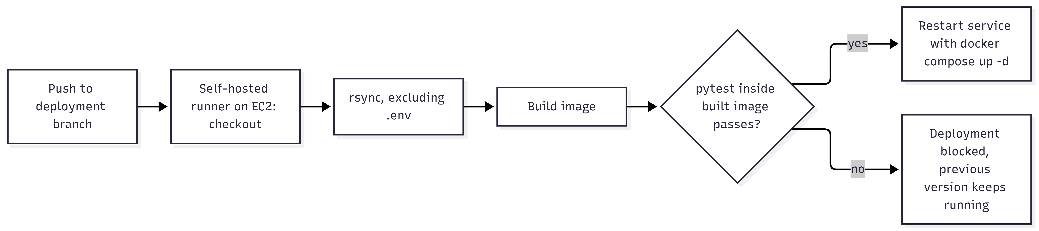
Figure 5.4: Test-gated deployment pipeline
In operation, health endpoints feed a status page, long-running work (crawling, exploration, execution and validation) runs off the request path with progress streamed to the dashboard, and the public Swagger documentation lets the other teams integrate without reading the code.

RESULTS AND VALIDATION
Generated tests passed 72.7% of 249 scenario runs across 65 executions, every story reached Gherkin, and the validation gate found real defects in stored suites and repaired one as a new version. This chapter reports these research results, the product and technical results, stakeholder and integration validation, and a summary of findings. Results that depend on runs still to be completed are marked as placeholders and are not claimed.

Research results

Generation quality
All numbers in this subsection are read from the production database by the evaluation script and reflect the behaviour of real generated tests against SauceDemo (Table 6.1).
Table 6.1: Generation-quality metrics (live database)
Metric | Value
Stories with Gherkin | 12 / 12 (100%)
Gherkin approved by QA | 7 / 12 (58%)
Active test suites | 3 (Playwright, Selenium, Cypress)
Executions logged | 65 (34 GitHub Actions, 31 local)
Scenario runs | 249
Passed / failed / error | 181 / 60 / 8
Test pass rate | 72.7%

Every story reached a Gherkin feature, so the coverage target was met in full. Of the 249 scenario runs, 24.1% failed on an assertion and 3.2% ended in an error. Executions were split almost evenly between GitHub Actions and the local runner, which shows that both execution paths were used in practice. Figure 6.1 shows the funnel from stories to passing runs, and Figure 6.2 the outcome of every scenario run.
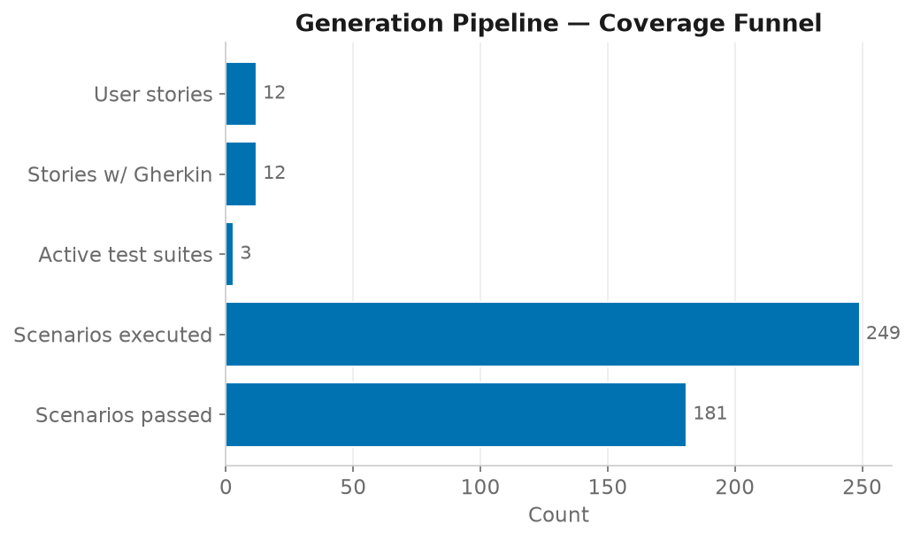
Figure 6.1: Coverage funnel from stories to passing runs
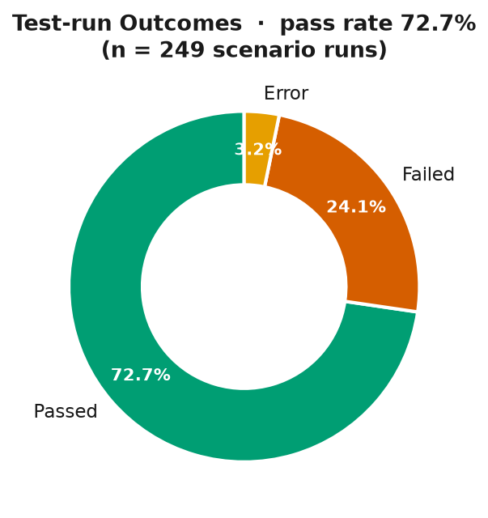
Figure 6.2: Test-run outcomes

Pass rate by flow
Pass rates differ by flow (Table 6.2 and Figure 6.3). Login scenarios passed 81.9% of 94 runs, while cart scenarios passed 66.7% of 102 runs, a gap of 15.2 percentage points; checkout lies between them at 70.6% of 51 runs. The two runs classified as “other” are too few to interpret.
Table 6.2: Pass rate by flow
Flow | Pass rate | Runs
login_flow | 81.9% | 94
checkout | 70.6% | 51
cart_ops | 66.7% | 102
other | 0% | 2

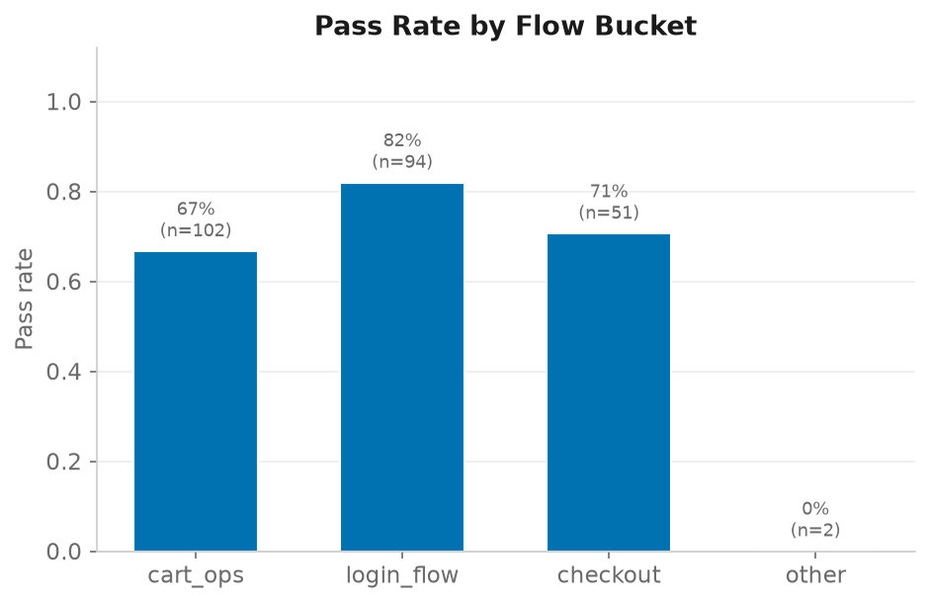
Figure 6.3: Pass rate by flow
The flow with stable, unique element ids and a single page (login) passes most often. The flows whose correctness depends on application state and multi-step sequences, such as toggling add-to-cart buttons and the two-step checkout, pass least often. Section 7.1 interprets this pattern against RQ1.

Independent validation gate
The validator was run on the active suites of the SauceDemo project, with gpt-4o as the judge and gpt-4o-mini as the original generator (Table 6.3).
Table 6.3: Validation gate results on live suites
Artefact | Static score | Judge score | Scenarios predicted to pass | Final score and verdict | Key findings | Judge time
Playwright suite v28 | 87 | 70 | 3 / 8 | 40, likely failing | One Gherkin scenario had no implementing test (the Gherkin had been edited after generation); 6 selectors unverified by the inventory-page crawl; the judge flagged a checkout step contradicting the scenario | 11.2 s
Selenium suite v2 | 90 | Not run | Not run | Static only in this run | 5 unverified selectors; 2 leftover TODOs; after helper-aware assertion detection, no vacuous tests | Not run
Cypress suite v3 | 97 | Not run | Not run | Static only in this run | 7 unverified selectors | Not run
Gherkin “Remove a product from the cart” | 100 | 85 | 1 / 2 | 78, needs review | Ambiguous outcome for the empty-cart scenario; semantic coverage of both acceptance criteria reported | 8.3 s

The Playwright result shows how the scoring rules of Table 4.8 work in practice. The scenario rate was 3 of 8, or 38, so the weighted base was 0.5 × 70 + 0.3 × 38 + 0.2 × 87 = 63.8. The judge reported a critical finding, which capped the score at 40, and the static major finding (the missing scenario) would independently have capped it at 85. The final score of 40 with the verdict likely_failing therefore reflects a concrete, explainable defect rather than an opaque number; the full report is reproduced in Appendix A. For the Gherkin feature, the base of 0.5 × 85 + 0.3 × 50 + 0.2 × 100 = 77.5 rounds to 78, just below the threshold of 80 for ready, because the judge was uncertain about the observable outcome of one scenario.
An auto-fix on the Playwright suite produced four described changes: it implemented the missing scenario, filled the postal code in the successful-checkout test, kept the verified cart-badge selector and added the corresponding test function. After the fix, the deterministic findings reduced to the single unverified-selector note, and the proposal was 95 lines long against 91 originally.
Calibration: the summary endpoint returned a calibration row for the Playwright suite, joining its validation report with its latest finished execution.

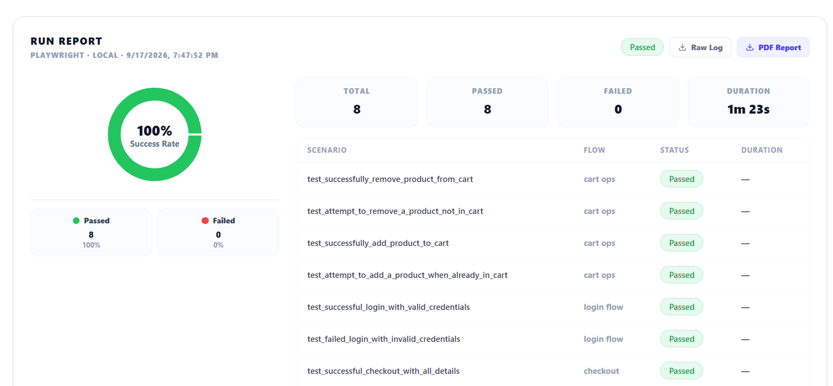
Figures 6.4 to 6.6 show how these results are presented to the QA engineer.
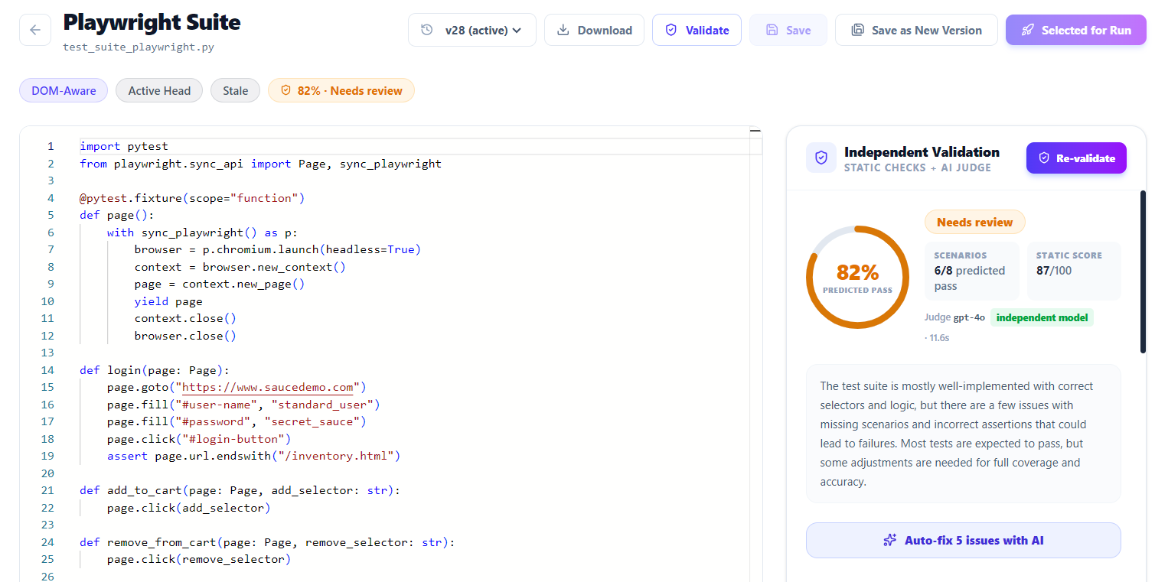
Figure 6.4: Validation panel in the suite editor
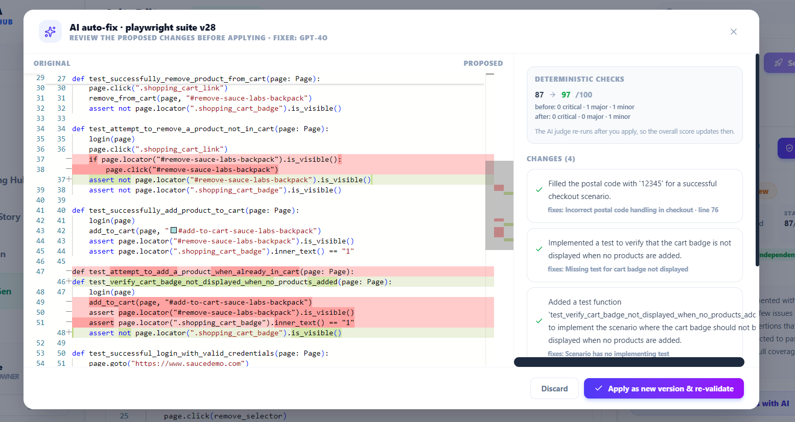
Figure 6.5: Auto-fix diff dialog with change log
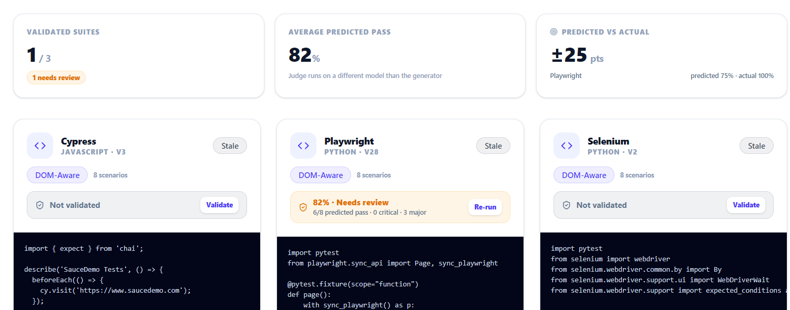
Figure 6.6: Gherkin editor with validation panel and acceptance-criteria coverage
A first smoke run used gpt-4o-mini as the judge, with the crawled element map presented as the complete set of existing elements. Its behaviour, and the correction that followed, are reported as Finding F3 in Section 6.5.

Agent explorer
With the defaults of 12 maximum steps and a plateau limit of 3, exploration runs on SauceDemo terminate by plateau or by the agent's own stop in a bounded number of steps, and emit discovered scenarios that can be approved into the pipeline (Figure 6.7).
Figure 6.7: Agent Explorer live view with Set-of-Mark overlay and reasoning cards

Risk model
The risk model was trained and tested on the synthetic bootstrap dataset (Table 6.4). These figures validate the training and inference pipeline; they are not evidence of real-world predictive power.
Table 6.4: Risk model metrics (1,600 training and 400 test rows, SMOTE, random_state 42, synthetic data)
Metric | Value
Accuracy | 94.25%
Macro-F1 | 94.34%
Decision-tree baseline accuracy | 94.25%
LOW precision / recall / F1 (n = 134) | 0.949 / 0.970 / 0.959
MEDIUM precision / recall / F1 (n = 160) | 0.925 / 0.931 / 0.928
HIGH precision / recall / F1 (n = 106) | 0.961 / 0.925 / 0.942
Top feature importance | past_pass_rate, 0.58
The confusion matrix shows errors only between adjacent classes (Figure 6.8). The per-class metrics are balanced (Figure 6.9). Feature importance is dominated by past_pass_rate (Figure 6.10), the feature from which the label was derived, and Figure 6.11 shows the class distribution of the training set. The identical accuracy of the random forest and the decision-tree baseline is discussed as Finding F6.
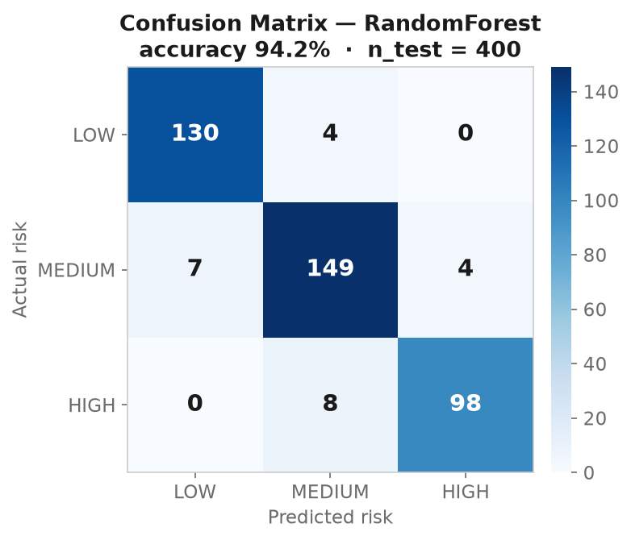
Figure 6.8: Risk model confusion matrix
Figure 6.9: Risk model per-class metrics
Figure 6.10: Risk model feature importance
Figure 6.11: Training-set class distribution

Product and technical results
All twelve functional requirements are implemented in the deployed service (Table 6.5).
Table 6.5: Functional requirements delivered
ID | Delivered as
FR1 | “Import from Meetings” with MoSCoW mapping and idempotent bulk upsert; manual entry with acceptance criteria
FR2 | Template-first Gherkin generation with LLM fallback; edit, regenerate and approve; only approved Gherkin feeds code generation
FR3 | Probe and crawl with authentication plans; element map with roles and confidence; QA editing and bulk approval
FR4 | Abstract and DOM-aware generation for Playwright, Selenium and Cypress in parallel; versioned suites with stale detection
FR5 | Monaco suite editor with autosave, save as new version, history restore and select for run
FR6 | Local and GitHub Actions execution with WebSocket logs, live frames, screenshots, per-scenario rows, PDF report and re-run
FR7 | GitHub connection with Fernet-encrypted token and automatic workflow installation
FR8 | Agent explorer from a one-sentence intent with live reasoning, actions, scenarios and coverage
FR9 | Validation of Gherkin and suites with score ring, per-scenario predictions, line-anchored findings and score breakdown
FR10 | Auto-fix proposal with diff and change log; applied as a new version and re-validated with a parent report
FR11 | Risk level per flow on the Code Review page
FR12 | Failed-tests, selectors and traceability endpoints consumed by Components 3 and 4

Against the non-functional requirements, validation took 11.2 s for a suite and 8.3 s for a Gherkin feature, within the 20 s limit of NFR3, and code generation for the three frameworks runs in parallel. The 37 automated tests run inside the image and block deployment on failure (NFR4), the security measures of NFR1 are in place, and every suite and report carries the content hashes required by NFR7. Figures 6.12 and 6.13 show the Code Review and Execution pages.
Figure 6.12: Code Review page with validation badges and summary strip
Figure 6.13: Execution page with live log, screenshots and PDF report

User or stakeholder validation
Three forms of stakeholder validation are available at the time of writing.
QA approval in the workflow. Seven of the twelve generated Gherkin features (58%) were approved through the QA approval step. Approval is a deliberate gate: only approved features reach code generation, so the approval rate records how much generated Gherkin a reviewer was willing to send downstream.
Supervisor and panel review. Feedback at the proposal, progress and final presentations shaped the requirements. Most significantly, the panel's request for an independent validation mechanism became the validation gate, the main addition of the second design cycle.
Integration partners. The owners of Components 1, 3 and 4 integrated against the component's documented endpoints, which is evidence that its interfaces meet the needs of their consumers (Section 6.4).
A structured practitioner evaluation of Gherkin quality, with a target mean rating of at least 4 out of 5, has not yet been carried out. [Insert the survey result here (number of respondents, mean rating, inter-rater agreement), or keep this paragraph and list the study as future work.]

Integration results
The integration endpoints are live and are consumed by Components 3 and 4. Stories imported from Component 1 keep their original UUIDs, so repeated imports are idempotent and each story traces back to its meeting. Every execution persists per-scenario rows, which already feed the traceability matrix of Component 4 and the validator's calibration. The gateway forwards both REST and WebSocket traffic, and the integration tests confirm that the service boots with all routers and that the seven validation paths are registered (TC23). The public OpenAPI documentation (Figure 6.14) is the contract the other teams integrate against.
Figure 6.14: Public OpenAPI (Swagger) documentation of the Component 2 service

Summary of findings

Table 6.6 compares the results with the targets set at the proposal stage.
Table 6.6: Targets versus achieved
Metric | Target | Achieved | Status and note
Story-to-Gherkin coverage | ≥ 80% | 100% (12 / 12) | Met
Executability and pass rate (Mode B) | ≥ 85% | 72.7% pass | Not met as a pass rate. Pass rate is stricter than executability, and failures include real differences in application behaviour, which Component 3 classifies
Generation latency | < 10 s per scenario | Met in operation; [insert measured value] | Three frameworks generated in parallel
Validation latency | < 20 s per suite | 11.2 s per suite; 8.3 s per Gherkin feature | Met, with gpt-4o as judge
Risk model | Precision ≥ 0.80, recall ≥ 0.75 | Precision 0.93 to 0.96; recall 0.93 to 0.97 | Met on synthetic data only; pipeline validation
Deployment gate | Tests block release | 37 tests run inside the image | Met
Human evaluation of Gherkin | ≥ 4 / 5 | [insert survey result or mark as future work] | Pending
Six research findings emerge from these results.
F1. Grounding and application knowledge are the main levers on executability. Flows with stable, unique ids (login) pass far more often than flows whose correctness depends on application state and multi-step sequences (cart and checkout). The deterministic sanitizer and the SauceDemo rules in the prompt were introduced because the same anti-patterns recurred regardless of prompt wording, which supports the literature finding that validation and repair, rather than first-shot generation, determine quality.
F2. Stale inputs are a real and detectable failure mode. The validator's single major static finding on the live Playwright suite was a Gherkin scenario with no implementing test, caused by the Gherkin being edited after the suite was generated. Hash-based staleness on suites and content hashes on validation reports make this class of drift visible to the QA engineer.
F3. A partial element map must be presented as evidence, not as truth. When the judge was first run on gpt-4o-mini with the crawled map presented as the set of existing elements, it declared the login selectors non-existent, because the crawl had covered only the inventory page, and the fixer replaced a correct selector with an unrelated one. Rewording the prompts to state that the map is partial, adding verified application facts and defining a severity scale corrected the behaviour on gpt-4o. This is a concrete, reproducible instance of the caution in the LLM-as-a-judge literature that the rubric and the framing of evidence determine the verdict.
F4. Independence of the judge is cheap to obtain and visibly changes the result. Pinning the validator to a different model required only configuration. The stronger judge produced calibrated per-scenario reasons and did not repeat the static findings, whereas the weaker judge was confidently wrong. Because each report records which model judged, this effect can be measured systematically.
F5. Explainable scoring is easier to defend than a single number. The breakdown of weights, caps, counts and model, together with line-anchored findings, makes the predicted pass rate defensible to a reviewer and gives the auto-fix a precise scope.
F6. The risk model's synthetic bootstrap validates the pipeline, not the prediction. The identical accuracy of the random forest and the decision-tree baseline, and the dominance of the feature from which the label was derived, show that the model recovers the rule that generated the data. The contribution is the end-to-end path from execution history to risk badges; the scientific claim must rest on APFD over real seeded faults.

DISCUSSION
The results support the design of Component 2 but do not yet answer every research question with controlled evidence. This chapter interprets the findings against the research questions, compares them with the literature and existing solutions, states the research and product contributions, examines limitations and threats to validity, and draws implications for practice and research.

Interpretation of findings
RQ1 - Grounding. The infrastructure needed to measure the grounding effect is complete: both generation modes, hash-tracked inputs and per-scenario persistence. The operational evidence is consistent with the hypothesis. Generated tests passed 72.7% of 249 real runs, and the pass rate depends on the flow: 81.9% for login, with stable unique ids on one page, against 66.7% for cart operations, whose correctness depends on state. Finding F1 shows that grounding alone is not enough; knowledge of stateful behavior, encoded in prompt rules and in the deterministic sanitizer, is the second lever. However, the controlled ablation of Mode A, Mode B and a naive zero-shot baseline on the same stories, with mean and standard deviation over at least five runs, has not been executed. RQ1 is therefore supported operationally but not yet answered experimentally, and the ablation is the first item of future work.
RQ2 — Discovery. The agent discovers behavior from a one-line intent and stops on its own, and the coverage-plateau criterion bounds exploration in practice. The headline comparison against a breadth-first crawler and a random walker at an equal step budget, and the ablation of reflexion memory, are specified in Section 3.3.6 and must be reported with the figures collected during the final demonstration runs before RQ2 can be answered.
RQ3 — Validation. The answer is yes, with qualifications. The gate predicts outcomes per scenario, concrete surfaces, line-anchored defects from two independent sources, and repairs them under human review. It caught a real coverage gap caused by Gherkin drift (F2) in a stored suite, and its scoring made the verdict on that suite explainable (F5). Its weaknesses are the judge's sensitivity to the framing of evidence (F3) and the lexical nature of the scenario-coverage and acceptance-criteria checks, which can produce false negatives when titles are paraphrased. Calibration against executions is implemented and must be reported over a larger set of executed, validated suites.
RQ4 — Prioritization and integration. The integration endpoints are live and consumed by Components 3 and 4, and every execution persists per-scenario rows that already feed the traceability matrix and the validator's calibration. The integration of half of RQ4 is therefore answered. The prioritization half is answered in the negative for classifier accuracy (F6): a model bootstrapped on synthetic data can only be defended as a prioritization mechanism evaluated by APFD on SauceDemo's seeded-defect accounts, which is planned.

Comparison with literature baselines and existing solutions
Because the controlled experiments have not yet been run, this comparison is qualitative. No numeric comparison with results reported in the literature is claimed.
Unit-test generation. TestPilot [5] and ChatUniTest [6] found that feeding errors back and repairing output, rather than the first generation, drives quality. Finding F1 reaches the same conclusion for UI tests, where it is harder to act on because correctness depends on the running application. Component 2 contributes a deterministic analogue of their feedback, the sanitizer, together with a validate-and-repair loop that works before execution.
Grounding. Work on LLM-driven GUI testing reports that grounding prompts in real page structure improves executability [8]. The per-flow pattern in Table 6.2 is consistent with that report, but only the planned Mode A versus Mode B ablation can quantify the effect for this component.
Web agents. WebVoyager [10] and AppAgent [11] evaluate task success. Component 2 adopts their grounding and memory techniques [9], [12] but changes the objective from completing a task to covering an application, which requires the stopping rule they lack. Task-success figures are therefore not a meaningful baseline; the breadth-first crawler and random walker comparisons are.
LLM-as-a-judge. Zheng et al. [19] measured judge agreement with human raters and warned of self-enhancement bias. Findings F3 and F4 are concrete instances of their cautions: the framing of evidence changed the verdict, and a judge on a different, stronger model behaved better. Component 2 also offers an objective reference that open-ended tasks lack, namely the actual execution outcome, against which the judge's predictions can be calibrated.
Code review. Bacchelli and Bird [20] found that review comments must be actionable to be adopted. The gate's findings carry a line, a snippet and a suggestion, and the fixer acts on exactly those findings, which gives the auto-fix a defined scope.
Prioritisation. The literature evaluates prioritisation by fault detection rather than classification accuracy [14], [16]. Finding F6 confirms why: on synthetic data, accuracy measures how well a model recovers the generator's rule.
Existing products. Against the tool families of Table 2.1, Component 2 is the only approach that combines generation from requirements, grounding, autonomous discovery, CI/CD execution, independent validation and traceability. Record-and-playback tools still offer deterministic locators for the flows a human records, and mature test-management products offer richer reporting and governance; Component 2 complements rather than replaces them.

Research contribution
The thesis makes four research contributions, each addressing one gap of Section 2.5.
- Coverage-driven agentic exploration for test discovery (G2). The transfer of Set-of-Mark grounding, single-call multi-role reasoning and reflexion memory from task completion to test discovery, with a stopping rule based on a plateau of novel UI-state hashes.
- Dual-mode generation with hash-tracked inputs (G1). Abstract and DOM-aware generation from the same approved Gherkin, with input hashes stored on every suite, which turns the grounding effect into a measurable variable rather than an assumption.
- An independent, explainable validation gate for LLM-generated UI tests (G3). Deterministic checks and a judge pinned to a different model, combined by a documented, capped score, with line-anchored findings, reviewable repairs linked to their parent reports, and calibration against real executions. The analysis of evidence framing (F3) and judge independence (F4) adds empirical observations to the LLM-as-a-judge literature in a new domain.
A closed, persisted loop from requirement to CI result (G4). Per-scenario results from local and GitHub Actions execution, persisted with flow labels and consumed by downstream failure analysis, traceability and validator calibration

Product contribution
The product contribution is a deployed, integrated service rather than a prototype. It comprises a FastAPI micro-service with documented REST and WebSocket APIs; two dashboard modules covering the full pipeline from story to execution, with a suite editor, version history, validation panel and diff-based auto-fix; local and GitHub Actions execution with live streaming, screenshots and PDF reports; and integration with the three other components of NextGen QA through the shared gateway. The service runs on AWS behind HTTPS with a deployment pipeline that refuses to release on a failing test.
Several design patterns are reusable beyond this project: content hashes for staleness and report currency, a deterministic sanitizer behind probabilistic generation, a validation score with documented caps, and marker-delimited repair output with a change log mapped to findings.

Limitations and threats to validity
Internal validity. The risk label is derived from one of the model's own features, so classifier accuracy is inflated by construction. LLM non-determinism affects every generation and judgement, so repeated runs with mean and spread are required before any comparison is claimed.
External validity. The evaluation uses one primary benchmark. SauceDemo's clean element ids flatter selector grounding, so secondary targets such as the OrangeHRM demo and the-internet test site should be evaluated.
Construct validity. The pass rate conflates generation defects with application defects. The fault-detection experiment on the seeded-defect accounts, comparing the standard user with the problem, error and visual users, separates the two, and Component 3's classification attributes individual failures.
Conclusion validity. The validator was evaluated on a handful of stored suites, which is too few for statistical claims. The mechanism is demonstrated; its measurement is pending.
Limitations of the artefact. The component generates UI tests only. The agent and the judge send screenshots and code to external providers unless a local model is configured. The crawl is single-level and must be run per page, so unverified-selector findings are expected until all pages are crawled. The fixer cannot resolve findings that require information it does not have, such as uncrawled selectors, and marks them as manual. Validator and generator share one API key budget.

Implications
For practitioners. Generated UI tests should not be accepted on the generator's word. An independent judge is cheap to obtain, requiring only configuration, but it should sit behind deterministic checks that cannot be outvoted. Evidence given to a judge, such as a crawled element map, should be presented as partial unless it is known to be complete. Tracking the hashes of the inputs from which a suite was generated catches drift that otherwise surfaces only as unexplained failures.
For researchers. Evaluations of LLM test generators should report execution-based outcomes, the model used to judge, and repeated-run statistics. Stopping rules for exploratory agents are an open research question in their own right. Accuracy on synthetic bootstrap data should not be presented as predictive performance.
For the NextGen QA platform. Because every execution is persisted per scenario with a flow label, the data needed to retrain the risk model on real history, to calibrate the validator and to evaluate Component 3's classification is already accumulating as the platform is used.

COMMERCIALISATION AND SUSTAINABILITY
Component 2 has a clear commercial position as the generation and validation core of NextGen QA: it answers the first question any buyer asks about AI-generated tests, “how do I know they are right?”. This chapter sets out its value proposition, competitive position, business and sustainability model, scalability, intellectual-property and compliance considerations, and its contribution to the Sustainable Development Goals.

Value Proposition and Target Users
Target market. Software teams practising Agile with CI/CD: in-house QA teams, development agencies and SaaS companies. There is a strong fit with regulated domains such as finance and health, which must evidence requirement-to-test traceability and independent verification of their test assets.
Target users. QA engineers, who review and approve generated Gherkin, suites and fixes; QA leads, who need an auditable record of what was generated, judged and changed; developers, who connect repositories and consume results in CI; and, in regulated organisations, audit and compliance staff, who need evidence of independent verification.
Value proposition. The platform aims to compress the time from a spoken requirement to a passing, traceable, validated automated test from hours to minutes. It reduces test-maintenance cost through DOM-grounded generation, an autonomous explorer that finds behaviour humans forget to specify, and self-healing downstream in Component 3. And it gives QA leads an auditable validation record for every generated test: which model judged it, what was found and what was fixed.

Market and Competitive Position
The competing alternatives are the tool families compared in Table 2.1: record-and-playback and codegen tools, test-management tools, general-purpose LLM assistants and agent frameworks. Each solves one slice of the problem. Component 2's differentiators are:
- The closed loop. Generate, validate, run, analyse, heal and trace in one platform, which point tools do not offer.
- The validation gate. Independent, explainable validation with reviewable repairs, addressing the main objection to AI-generated tests.
- LLM-agnostic design. Pluggable providers (Anthropic, OpenAI, Gemini, Ollama) avoid lock-in to a single model vendor and allow an on-premises deployment.
- Fit with existing stacks. Output is standard Gherkin and standard Playwright, Selenium or Cypress code committed to the customer's own repository through GitHub, so adoption does not require abandoning existing tools.

Business and Sustainability Model
Revenue model. A SaaS subscription per project or per seat, with a usage-based tier for LLM consumption; an on-premises option with a local model, which the provider layer already supports through Ollama, for enterprises that cannot send application screenshots to external APIs; and professional services for onboarding target applications.
Cost structure. LLM usage is the main variable cost. The design already contains it by using a small model for high-volume Gherkin and code generation and reserving larger models for the vision agent and the validator. Execution through GitHub Actions runs on the customer's own CI capacity, and the remaining infrastructure is containers and managed PostgreSQL. [Add indicative pricing only if it is supported by a costing exercise.]
Go-to-market. Start with teams already using Cucumber or Playwright, where generated Gherkin and code slot into existing repositories through the GitHub integration; then expand through the traceability and quality features of Components 3 and 4.
Sustainability of the product. The component is designed to be maintained: one module per pipeline stage, a single shared feature schema, idempotent migrations, OpenAPI documentation and a test-gated deployment. It also improves with use, because each execution adds the per-scenario history needed to retrain the risk model on real data and to calibrate the validator.

Scalability, Intellectual Property and Compliance
Scalability. The services are stateless behind a gateway, persistence is managed PostgreSQL, and everything is containerised. LLM calls are the main cost and latency driver, and they are parallelised per framework; long-running work runs off the request path. The current deployment is a single shared EC2 instance, and scaling beyond it has not yet been load-tested. [Add load-test results if available.]
Intellectual property. [State the ownership of the software and research outputs under the SLIIT intellectual-property policy, and any agreement within the team.] The component builds on open-source frameworks and libraries whose licences must be audited before any commercial release.
Compliance. Screenshots, DOM content and code of the target application are sent to the configured LLM provider. Customers handling personal data therefore need either a data-processing agreement with the provider or the local-model deployment, in line with applicable data-protection law such as Sri Lanka's Personal Data Protection Act No. 9 of 2022 or the GDPR for European customers. Encrypted credential storage, HTTPS, JWT-protected access and the audit trail of validation reports support security and audit requirements.

Contribution to the Sustainable Development Goals
SDG 9 — Industry, innovation and infrastructure. Software is part of modern infrastructure, and its reliability depends on testing. By making grounded, independently validated automated tests cheaper to produce, the component helps teams, including small firms without dedicated automation engineers, raise the quality of the software they ship.
SDG 8 — Decent work and economic growth. The component automates repetitive script writing and shifts QA engineers towards review, judgement and exploratory work, raising productivity through technological upgrading while keeping humans responsible for every approval.
Environmental responsibility. LLM inference consumes energy. The design limits it by reserving larger models for the tasks that need them, running high-volume generation on a small model, and using deterministic checks, which require no model, as the first line of validation.

CONCLUSION AND FUTURE DIRECTIONS

Conclusion
This thesis presented Component 2 of NextGen QA, an intelligent test case generation engine that takes Agile user stories to executable, UI-grounded, independently validated test suites and runs them in CI/CD. The artefact implements a template-first Gherkin generator with human approval; a DOM crawler that builds a semantic element map; a dual-mode, multi-framework code generator with a deterministic sanitizer and versioned suites; a vision-guided agent explorer with Set-of-Mark grounding, multi-role reasoning, reflexion memory and coverage-plateau termination; a local and GitHub Actions execution engine with live streaming and reporting; a random-forest risk model; and an independent validation gate that combines static analysis with an LLM judge on a different model, explainable scoring and reviewable auto-repair. The component is integrated with the other three components through a gateway, deployed on AWS behind HTTPS with a test-gated pipeline, and documented through OpenAPI.
Measured on the live system, generated tests passed 72.7% of 249 scenario runs across 65 executions, and every story reached Gherkin. The validation gate identified real defects in stored suites, including a scenario dropped through Gherkin drift and selectors that the crawl could not verify, and it repaired a suite as a new version without discarding the original. The risk model's 94% accuracy is reported for what it is: a validation of the pipeline on synthetic data. The central lesson of the work is that generation and validation must be designed together: what makes LLM-generated UI tests trustworthy is not a better first draft but grounding, deterministic checks, an independent judge and a loop that compares predictions with real outcomes.

Achievement of Objectives
Table 9.1 reviews each sub-objective of Table 1.1 against the evidence in Chapter 6.
Table 9.1: Achievement of sub-objectives
# | Sub-objective (short) | Status | Evidence
SO1 | Gherkin from stories with QA approval | Achieved; practitioner rating pending | 12 / 12 stories covered; 7 / 12 approved; acceptance-criteria traceability checks implemented
SO2 | Live crawl into a semantic element map | Implemented; accuracy measurement pending | Crawler with authentication plans, roles and confidence; selector accuracy against manual ground truth not yet measured
SO3 | Multi-framework, dual-mode generation | Implemented; per-mode comparison pending | Playwright, Selenium and Cypress in two modes with the sanitizer; 72.7% pass rate on DOM-aware suites; ablation pending
SO4 | Vision-guided agent with plateau stop | Implemented; baseline comparison pending | SoM agent with coverage-plateau termination; run statistics and breadth-first comparison pending
SO5 | Local and GitHub Actions execution | Achieved | 65 executions (34 GitHub Actions, 31 local) with logs, screenshots, PDF reports and re-run
SO6 | Independent validation with auto-fix | Largely achieved | Static checks and a judge on a different model, explainable capped score, auto-fix as a new version; calibration at scale pending
SO7 | Risk-based prioritisation | Partially achieved | Model and risk badges in place on synthetic data; APFD on seeded faults planned
SO8 | Integration and test-gated deployment | Achieved | Endpoints consumed by Components 3 and 4; Component 1 import live; 37 tests gate every deployment
The main objective is therefore met as a working, integrated artefact. Its research evaluation is complete for the validation gate's mechanism and for operational generation quality, and is specified but incomplete for the grounding ablation, the exploration baseline and prioritisation by APFD.

Individual Research and Product Contributions
The author's individual research contributions are: (1) coverage-driven agentic exploration applied to test discovery; (2) dual-mode generation with hash-tracked inputs that makes the grounding effect measurable; (3) an independent, explainable validation gate for LLM-generated UI tests with execution calibration; and (4) a closed, persisted loop from requirement to CI result that downstream failure analysis and traceability consume.
The individual product contribution is the complete Component 2 service and its two dashboard modules: every backend module of Table 5.2, the validation and auto-fix interface, the execution engine with two runners, the integration endpoints used by the other components, the 37 automated tests and the component's test-gated deployment. The shared gateway, authentication service and AWS deployment were built jointly with the team (Section 1.8).

Future Directions
In order of priority, future work should:
- Run the Mode A, Mode B and naive-LLM ablation with repeated runs, reporting mean and standard deviation, to answer RQ1.
- Run the fault-detection experiment on SauceDemo's seeded-defect accounts, and measure APFD for risk-ordered execution.
- Retrain the risk model on the real execution rows that this evaluation produces, replacing the synthetic bootstrap.
- Report validator calibration and fix effectiveness over a larger set of executed suites, with judge and generator on the same versus different models.
- Compare the agent explorer with a breadth-first crawler and a random walker at an equal step budget, and ablate reflexion memory.
- Extend the crawler to multi-page exploration so that selector grounding is complete.
- Replace lexical scenario and acceptance-criteria matching with embedding similarity to reduce false negatives on paraphrased titles.
- Conduct the practitioner study with inter-rater agreement, and evaluate secondary targets such as the OrangeHRM demo and the-internet.

REFERENCES
[Verify every reference against the original publication before submission, and add any sources cited in the team paper. Every entry below is cited in the text.]
[1] D. North, “Introducing BDD,” Better Software Magazine, 2006.
[2] M. Wynne, A. Hellesøy, and S. Tooke, The Cucumber Book: Behaviour-Driven Development for Testers and Developers, 2nd ed. Raleigh, NC, USA: Pragmatic Bookshelf, 2017.
[3] Y. Deng, C. S. Xia, H. Peng, C. Yang, and L. Zhang, “Large language models are zero-shot fuzzers: Fuzzing deep-learning libraries via large language models,” in Proc. ACM SIGSOFT Int. Symp. Software Testing and Analysis (ISSTA), 2023.
[4] J. Wang, Y. Huang, C. Chen, Z. Liu, S. Wang, and Q. Wang, “Software testing with large language models: Survey, landscape, and vision,” IEEE Trans. Softw. Eng., vol. 50, no. 4, pp. 911–936, 2024.
[5] M. Schäfer, S. Nadi, A. Eghbali, and F. Tip, “An empirical evaluation of using large language models for automated unit test generation,” IEEE Trans. Softw. Eng., vol. 50, no. 1, pp. 85–105, 2024.
[6] Z. Xie, Y. Chen, C. Zhi, S. Deng, and J. Yin, “ChatUniTest: A framework for LLM-based test generation,” in Companion Proc. ACM Int. Conf. Foundations of Software Engineering (FSE Companion), 2024.
[7] C. Lemieux, J. P. Inala, S. K. Lahiri, and S. Sen, “CodaMosa: Escaping coverage plateaus in test generation with pre-trained large language models,” in Proc. IEEE/ACM Int. Conf. Software Engineering (ICSE), 2023.
[8] Z. Liu et al., “Make LLM a testing expert: Bringing human-like interaction to mobile GUI testing via functionality-aware decisions,” in Proc. IEEE/ACM Int. Conf. Software Engineering (ICSE), 2024.
[9] J. Yang, H. Zhang, F. Li, X. Zou, C. Li, and J. Gao, “Set-of-Mark prompting unleashes extraordinary visual grounding in GPT-4V,” arXiv:2310.11441, 2023.
[10] H. He et al., “WebVoyager: Building an end-to-end web agent with large multimodal models,” in Proc. Annu. Meeting of the Association for Computational Linguistics (ACL), 2024.
[11] C. Zhang et al., “AppAgent: Multimodal agents as smartphone users,” arXiv:2312.13771, 2023.
[12] N. Shinn, F. Cassano, A. Gopinath, K. Narasimhan, and S. Yao, “Reflexion: Language agents with verbal reinforcement learning,” in Proc. Advances in Neural Information Processing Systems (NeurIPS), 2023.
[13] S. Hong et al., “MetaGPT: Meta programming for a multi-agent collaborative framework,” in Proc. Int. Conf. Learning Representations (ICLR), 2024.
[14] G. Rothermel, R. H. Untch, C. Chu, and M. J. Harrold, “Prioritizing test cases for regression testing,” IEEE Trans. Softw. Eng., vol. 27, no. 10, pp. 929–948, 2001.
[15] S. Elbaum, A. G. Malishevsky, and G. Rothermel, “Test case prioritization: A family of empirical studies,” IEEE Trans. Softw. Eng., vol. 28, no. 2, pp. 159–182, 2002.
[16] R. Pan, M. Bagherzadeh, T. A. Ghaleb, and L. Briand, “Test case selection and prioritization using machine learning: A systematic literature review,” Empirical Softw. Eng., vol. 27, Art. no. 29, 2022.
[17] L. Breiman, “Random forests,” Machine Learning, vol. 45, pp. 5–32, 2001.
[18] N. V. Chawla, K. W. Bowyer, L. O. Hall, and W. P. Kegelmeyer, “SMOTE: Synthetic minority over-sampling technique,” J. Artificial Intelligence Research, vol. 16, pp. 321–357, 2002.
[19] L. Zheng et al., “Judging LLM-as-a-judge with MT-Bench and Chatbot Arena,” in Proc. Advances in Neural Information Processing Systems (NeurIPS) Datasets and Benchmarks Track, 2023.
[20] A. Bacchelli and C. Bird, “Expectations, outcomes, and challenges of modern code review,” in Proc. IEEE/ACM Int. Conf. Software Engineering (ICSE), 2013.
[21] A. R. Hevner, S. T. March, J. Park, and S. Ram, “Design science in information systems research,” MIS Quarterly, vol. 28, no. 1, pp. 75–105, 2004.
[22] K. Peffers, T. Tuunanen, M. A. Rothenberger, and S. Chatterjee, “A design science research methodology for information systems research,” J. Management Information Systems, vol. 24, no. 3, pp. 45–77, 2007.
[23] M. Chen et al., “Evaluating large language models trained on code,” arXiv:2107.03374, 2021.
[24] Microsoft, “Playwright documentation.” [Online]. Available: https://playwright.dev (accessed [date], 2026).
[25] Sauce Labs, “Swag Labs demo application.” [Online]. Available: https://www.saucedemo.com (accessed [date], 2026).
[26] Y. Jia and M. Harman, “An analysis and survey of the development of mutation testing,” IEEE Trans. Softw. Eng., vol. 37, no. 5, pp. 649–678, 2011.

GLOSSARY
Acceptance criterion — A condition that a user story must satisfy to be accepted; each should be covered by at least one Gherkin scenario.
Agent explorer — The component's vision-guided agent that explores a web application from a one-sentence intent and proposes test scenarios.
Auto-fix — An LLM-proposed repair of selected validation findings, shown as a diff and applied only as a new version after human approval.
Calibration — The comparison of the validator's predicted pass rate with the pass rate actually observed when the suite is executed.
Coverage plateau — A run of consecutive exploration steps (three by default) in which no previously unseen UI state is reached; used to stop the agent.
DOM grounding — Generating test code with selectors captured from the live page rather than guessed by the model.
Element map — The stored set of crawled interactive elements for a URL, each with a selector, a semantic role and a confidence score.
Flow bucket — The category of a scenario (login, cart, checkout, search or other) used to aggregate results and predict risk.
Gherkin — The Given, When, Then specification language used by BDD tools such as Cucumber.
LLM-as-a-judge — The use of one language model to grade the output of another against a rubric.
Mode A and Mode B — Abstract generation with locator placeholders (Mode A) and DOM-aware generation with crawled selectors (Mode B).
Reflexion memory — Lessons recorded after failed actions and injected into later prompts so that the agent does not repeat mistakes.
Sanitizer — A deterministic post-processor that repairs known fatal code patterns without changing the meaning of correct code.
Seeded-defect account — A SauceDemo user account, such as the problem user, whose application behaviour contains deliberate defects.
Set-of-Mark — A prompting technique that overlays numbered marks on a screenshot so a vision model can refer to elements by number.
Stale suite — A suite whose stored input hash no longer matches the current approved Gherkin and element map.
State hash — The SHA-1 hash of a page URL and its sorted element fingerprints, used to recognise a UI state already seen.
Vacuous test — A test that cannot fail on a defect because it asserts nothing about the application.
Validation gate — The component's combination of deterministic checks, an independent LLM judge, explainable scoring, calibration and human review applied to generated artefacts.

Appendix A Extended Results and Sample Artefacts
This appendix reproduces representative artefacts generated and used by Component 2, cited from Chapters 2 to 6.

A.1 Generated Gherkin (login story, LLM generator, lean policy)
Feature: Login
Scenario: Successful login with valid credentials
Given the user is on the login page
When the user enters "standard_user" and "secret_sauce"
And clicks the login button
Then the user is redirected to the inventory page
Scenario: Login fails with invalid password
Given the user is on the login page
When the user enters "standard_user" and "wrong"
Then the error "Epic sadface: Username and password do not match any user in this service" is shown

A.2 Generated Playwright suite excerpt (Mode B, DOM-aware)
import pytest
from playwright.sync_api import sync_playwright, expect
BASE = "https://www.saucedemo.com/"
@pytest.fixture
def page():
with sync_playwright() as p:
browser = p.chromium.launch(headless=True)
pg = browser.new_page()
yield pg
browser.close()
def login(page, user, pwd):
page.goto(BASE)
page.fill("#user-name", user)
page.fill("#password", pwd)
page.click("#login-button")
def test_successful_login_with_valid_credentials(page):
login(page, "standard_user", "secret_sauce")
expect(page).to_have_url("https://www.saucedemo.com/inventory.html")
def test_login_fails_with_invalid_password(page):
login(page, "standard_user", "wrong")
assert "Epic sadface" in page.locator("[data-test='error']").inner_text()

A.3 Validation report for Playwright suite v28 (abridged JSON)
{
"target_type": "suite",
"score": 40,
"verdict": "likely_failing",
"static_score": 87,
"llm_score": 70,
"scenario_total": 8,
"scenario_pass_predicted": 3,
"validator_model": "gpt-4o",
"breakdown": {
"weights": {"llm": 0.5, "scenario": 0.3, "static": 0.2},
"scenario_rate": 38,
"base": 63.8,
"caps_applied": ["judge critical -> cap 40", "major finding -> cap 85"],
"independent_model": true
},
"findings": [
{"severity": "major", "source": "static", "category": "coverage",
"title": "Scenario has no implementing test",
"detail": "No test matches the Gherkin scenario \"Verify cart badge is not displayed when no products are added\"."},
{"severity": "minor", "source": "static", "category": "selector_grounding",
"title": "Selectors not in crawled element map", "line": 16}
]
}

A.4 Judge prompt (abridged)
System: You are an independent senior QA automation reviewer. You did NOT write the code you are
reviewing and you must not trust it. Predict whether each generated test will PASS when executed
headlessly in CI against the real application, and list the concrete defects. Cite line numbers.
Never invent problems. Reply with a single JSON object.
User: Framework: playwright | Mode: DOM-aware | Target URL: https://www.saucedemo.com
Known facts about saucedemo.com (override gaps in the crawled map): ...
Gherkin scenarios the suite must implement: ...
Crawled DOM element map: IMPORTANT: the map is PARTIAL ... a selector absent from the map is
UNVERIFIED, not wrong ...
Deterministic checks already flagged these (do NOT repeat them): ...
Generated test suite (line-numbered): ...
Severity scale: critical = file will not collect or one root cause fails most tests; major = one
specific test fails or is vacuous; minor = fragile or unverified; info = observation.
Return ONLY this JSON: { "pass_probability": ..., "scenarios": [...], "findings": [...] }

A.5 Configuration of the evaluated deployment
LLM_PROVIDER=openai # generator provider
LLM_MODEL=gpt-4o-mini # generator model
LLM_API_KEY=...
AGENT_VISION_MODEL=gpt-4o # agent explorer
VALIDATOR_PROVIDER=openai # optional; defaults to LLM_PROVIDER
VALIDATOR_MODEL=gpt-4o # different from the generator for independence
DATABASE_URL=postgresql+asyncpg://...neon.tech/nextgen_qa
NEXTGENQA_CRYPTO_KEY=... # Fernet key for stored personal access tokens
NEXTGENQA_INTERNAL_KEY=... # shared header key for internal endpoints

A.6 Deployment workflow (abridged)
on:
push:
branches: [feature/aws-deploy]
jobs:
deploy:
runs-on: [self-hosted, nextgenqa]
steps:
- uses: actions/checkout@v4
- run: rsync -a --exclude='.git/' --exclude='.env' ./ ~/Intelligent-Test-Case-Generation/
- run: docker compose -f ~/deploy/docker-compose.prod.yml build test-case
- run: docker compose -f ~/deploy/docker-compose.prod.yml run --rm --no-deps
-v $PWD/backend/tests:/app/tests -v $PWD/backend/pytest.ini:/app/pytest.ini
test-case python -m pytest tests
- run: docker compose -f ~/deploy/docker-compose.prod.yml up -d test-case

A.7 Evaluation scripts
Table A.1: Evaluation scripts and outputs
Script or endpoint | Output
python -m app.ml.reports.generation_eval | generation_metrics.json, coverage funnel, run outcomes, pass rate by flow
python -m app.ml.train and python -m app.ml.reports.make_charts | metrics.json, confusion matrix, per-class metrics, feature importance, class distribution
python -m pytest tests | 37 unit and integration tests
GET /api/v1/validation/projects/{id}/summary | Validation counts, averages and predicted-versus-actual calibration

Appendix B Academic Integrity and AI Use Disclosure
The generative AI tools used in accordance with the module policy. The language models that form part of the artefact itself (gpt-4o-mini, gpt-4o and Claude Sonnet as generator, judge, fixer and vision agent) are research components described in Chapters 3 to 5, not writing aids.
Table B.1: Generative AI tools used
Tool | Purpose | Sections or artefacts affected | Verification performed
Claude (Anthropic), claude.ai | Code generation assistance during development: generating boilerplate code, debugging, refactoring backend modules, writing prompt templates for the LLM judge and fixer, and drafting unit test cases | Backend modules: gherkin/, dom_crawler/, code_gen/, validation/, execution/, agent_explorer/, ml/; frontend components: validation panel, fix dialog, score ring | All generated code was reviewed, tested against the live application, and verified through the 37 automated unit and integration tests; every module was manually inspected and modified before merging
GitHub Copilot | Inline code suggestions and autocompletion during development in VS Code | All backend and frontend source files | Suggestions were accepted selectively; each accepted suggestion was reviewed in context and tested before committing
ChatGPT (OpenAI) | Exploring design alternatives; drafting early prompt templates for the code generator and the judge; troubleshooting deployment issues | code_gen/ prompt assembly; validation/ judge and fixer prompts; Docker and Caddy configuration | Prompts were iterated against live output; deployment configurations were verified on the running EC2 instance

Appendix C Dashboard Screenshots
Screens already shown in Chapter 6 (Figures 6.4 to 6.7 and 6.12 to 6.14) are not repeated here.
Figure C.1: User Stories page with Import from Meetings
Figure C.2: Mode Setup page
Figure C.3: DOM Inspector
Figure C.4: Suite Editor with validation panel and jump-to-line
Figure C.5: GitHub Settings

Appendix D Similarity (Turnitin) Report
[Insert the Turnitin submission screenshot or similarity report summary.]

